**AN INTERNSHIP REPORT**

**On**

**Development of YOLOV12 & YOLOV11 Models for Aerial Target Object Detection and PCB Defects Detection**

***Submitted in partial fulfilment of requirements for B. Tech degree***

**Internship Work**

UNDER THE SUPERVISION OF:

## Ms. Archana

Scientist/Engineering – SD,

RCI, DRDO Hyderabad



SUBMITTED BY:

V Laxmi Narayan Sharma (21R01A7362)

Department of Artificial Intelligence and Machine Learning

2021-2025



**CMR Institute of Technology, Medchal, Hyderabad (Autonomous)**

## NAAC A+ Grade, NBA Accredited, Approved by A.I.C.T.E

**Kandlakoya Village, Medchal Rd, Hyderabad, Telangana 50140**

# CERTIFICATE

This is to certify that this internship report titled **“Development of Customized API for Land Use Land Covers Classification using ML techniques via open-source Platform”** is a record of the bonafide work carried out by ―**V Laxmi Narayan Sharma** under my guidance and supervision at the National Remote Sensing Centre, ISRO, Hyderabad during period 1st July 2024 to 30th September 2024. He has completed the assigned work satisfactorily.

The project report has not formed the basis for the award of any degree, diploma, associateship, fellowship or other titles.

I hereby confirm the originality of the work and that there is no plagiarism in any part of the project report.

**Mr. Dhiroj Kumar Behera**

Scientist/Engineer – “SE”

Land Use Land Cover

Mapping and Monitoring Division

National Remote Sensing Centre

Indian Space Research Organization

# DECLARATION

I solemnly affirm that the internship report titled **“Development of Customized API for Land Use Land Covers Classification using ML techniques via open-source Platform”** is a genuine record of our original work. It is an academic endeavour conducted under the guidance of the designated mentor and represents a comprehensive compilation of insights, research, and development work. The work, where necessary, has been properly attributed and referenced, acknowledging the intellectual contributions of others per academic norms and ethical guidelines.

The internship report has not formed the basis for the award of any degree, diploma, associateship, fellowship or other titles.

I hereby confirm the originality of the work and that there is no plagiarism in any part of the project report.

Date: 30th September 2024 V Laxmi Narayan Sharma

Place: Hyderabad B. Tech - Department of AI & ML

CMR Institute of Technology

Kandlakoya Village, Medchal Rd, Hyderabad, Telangana 501401

# ACKNOWLEDGEMENT

*We seize this moment to express our deepes* (hh)(hh)(Placeholder1)*t gratitude and profound respect to*

*all those who have been instrumental in the successful completion of this work.*

*Foremost, we extend our sincere appreciation to* ***Mr. Dhiroj Kumar Behera****,*

*Scientist/Engineer – SD, NRSC, for his invaluable mentorship and support. His*

*astute guidance and critical insights significantly shaped our approach to*

*development and experimentation. His commitment to excellence and*

*unwavering support have profoundly influenced our professional development.*

*He has always given us important knowledge and wisdom to successfully*

*complete this project.*

***Head, LUCMD*** *and* ***GH, SRLUMG*** *are deeply appreciated for their invaluable*

*support and guidance in the accomplishment of this Project. We are also very*

*grateful to* ***Avinash Imadiseety*** *for supporting and contributing towards this*

*project.*

*Following these remarkable individuals, we would like to express our gratitude*

*to* ***Smt. Savitha Sunkari*** *for offering us the chance to be part of such a*

*prestigious institution. Her faith in our capabilities and her support have been*

*instrumental in our personal and professional growth. The opportunity to work*

*under the National Remote Sensing Centre, ISRO, Land Use Land Cover*

*Division has been a privilege, and for that, we are eternally thankful.*

***V Laxmi Narayan Sharma***

# ABOUT RCI

The Research Centre Imarat (RCI) is one of India’s premier research institutions under the Defence Research and Development Organisation (DRDO), Ministry of Defence, Government of India. Located in Hyderabad, Telangana, RCI has played a pivotal role in the development of advanced avionics and missile systems, contributing significantly to India's strategic defense capabilities. Established in 1988, RCI has evolved into the backbone of India’s guided weapon development program and is considered the brainchild of Dr. A.P.J. Abdul Kalam, the Missile Man of India.

RCI is primarily tasked with the design, development, and integration of state-of-the-art avionics systems, including navigation, control, onboard computers, seekers, signal processing, and real-time mission software. These technologies are integral to the success of missile systems like Agni, Akash, Astra, Nag, and Prithvi, among others. The center is also home to a wide range of advanced laboratories and test facilities that support indigenous R&D across systems engineering, hardware-in-loop simulation, artificial intelligence, and electro-optical tracking systems.

In recent years, RCI has been at the forefront of incorporating cutting-edge technologies such as AI/ML, computer vision, and embedded systems into missile guidance and surveillance systems. Its interdisciplinary research spans across areas such as aerospace, signal processing, control theory, real-time computing, and software engineering. The institution also actively collaborates with other DRDO labs, Indian industries, and academia, promoting the spirit of self-reliance and innovation in defense technology.

Beyond its technical achievements, RCI is known for nurturing young talent through internships, training programs, and collaborative projects with engineering colleges and research institutions. It has cultivated a robust ecosystem that balances research excellence with national strategic priorities. With a legacy of excellence and a vision aligned with the Atmanirbhar Bharat initiative, RCI continues to push the boundaries of technology, securing India’s position as a leading power in defense innovation.

# ABSTRACT

YOLOV11 and YOLO12 models are very crucial and revolutionary in accurate and real-time object detection. This Project presents the development of YOLOv11 and YOLOv12 models for two important applications: Aerial Target Object Detection and PCB (Printed Circuit Board) Defects Detection.

For aerial target objects training the models were trained on UAV (Unmanned Aerial Vehicles) Dataset available on Kaggle which included Drones labelled data. In parallel another set of models were trained on PCB Defects Dataset available on Kaggle which focused on structural faults. Both tasks required meticulous preprocessing, annotation conversion to YOLO format, and robust training on YOLO model variants with customized hyperparameters.

To ensure reproducibility and deployment readiness, the entire Conda-based development environment—including model weights, inference scripts, and notebooks—was successfully packaged using Conda-pack. This enables binary-safe, portable, and offline deployment across isolated or air-gapped systems, such as embedded hardware or defense-grade field units.

The trained models demonstrated high accuracy, low inference latency, and strong generalization capability across both domains. This dual-capability project highlights the versatility and performance of next-generation YOLO architectures in solving diverse real-world detection challenges spanning aerospace surveillance and electronic manufacturing quality control.

# COMPUTATIONAL RESOURCES

**Software:**

* Primary Programming Language: Python 3 served as the foundation for the project, providing a versatile and well-established platform for data science tasks.
* Interactive Development Environment (IDE): Jupyter Notebook or Google Colab was utilised as the primary code editor.
* Data Analysis and Manipulation Libraries:
  + Pandas: This library provided essential functionalities for data manipulation, cleaning, transformation, and organisation.
  + NumPy: NumPy offered robust numerical computing capabilities, supporting array-based operations and mathematical functions crucial for data preprocessing and model training.
* Data Visualization Libraries:
  + Matplotlib, Seaborn, and Plotly: These libraries provided a comprehensivesuite of tools for creating informative and visually appealing data visualisations.
* Machine Learning Libraries:
  + Scikit-learn: This library encompasses a wide range of machine learning algorithms and tools. Depending on the chosen modelling approach, Scikitlearn could have been employed for model training, evaluation, and hyperparameter tuning.
  + TensorFlow: For deep learning approaches, TensorFlow provided a powerful framework for constructing, training, and deploying artificial neural networks.

**Hardware:**

The system, running Windows 11 Home Single Language (Version 23H2) with the AMD Ryzen 5 5500U processor and 16 GB RAM, provides a capable environment for multitasking, machine learning, and data analysis. The integrated Radeon Graphics support light GPU tasks, while the OS build 22631.4317 and Windows Feature Experience Pack ensure optimized performance and access to the latest Windows features. This combination of hardware and software is well-suited for productivity, development, and computational tasks.

Contents

Mr. Dhiroj Kumar Behera 1

NAAC A+ Grade, NBA Accredited, Approved by A.I.C.T.E 1

CERTIFICATE i

DECLARATION ii

ACKNOWLEDGEMENT iii

ABOUT NRSC iv

ABSTRACT vi

COMPUTATIONAL RESOURCES vii

LIST OF TABLES xii

LIST OF ABBREVIATIONS xii

CHAPTER 1 1

INTRODUCTION 1

1.1 Background 1

1.2 Problem Statement 5

1.3. Objectives of the Study 6

1.4. Scope of the Study 7

1.5. Significance of the Study 7

1.6. Structure of the Report 8

CHAPTER 2 LITERATURE REVIEW 11

2.1. LAND USE AND LAND COVER 11

2.2. REMOTE SENSING 12

2.2.a. REMOTE SENSING IN INDIA 12

2.2.b. Remote Sensing Platforms 12

2.3. Machine Learning Methods for LULC 14

2.4. Deep Learning in LULC 16

2.5. RESOLUTION & TYPES 21

2.6. GOOGLE EARTH ENGINE 22

2.7. Visual Interpretation of LULC Image 23

2.8. HYPER-PARAMETER-TUNING 26

2.8.1. Grid Search 26

2.8.2. Randomized Search 26

2.8.3. Bayesian Search in Hyperparameter Tuning 27

2.9. APPLICATIONS OF LULC CLASSIFICATION IN ENVIRONMENT AND URBAN MAPPING 28

CHAPTER 3 31

Methodologies and Algorithms 31

3.1. Introduction 31

3.1.1. Introduction to Methodologies 31

3.1.2. Data Acquisition and Preparation 31

3.2. Support Vector Models 33

3.2.1. SVM with Grid Search 33

3.2.2. SVM with Random Search 33

3.2.3. SVM Bayesian Search 34

3.3. Random Forest 34

3.3.1. Random Forest using Grid Search 34

3.3.2 Random Forest using Random Search 35

3.3.3. Random Forest using Bayes Search 35

3.4 Artificial Neural Network (ANN) 36

3.4.1. Data Preprocessing 36

3.4.2 Model Definition 37

3.4.2. Compiling the Model 38

3.4.3. Training the Model 38

3.4.4. Evaluating the Model 38

3.4.5. Evaluating the Model on New Data 38

3.4.6. Predicting New Labels 38

3.5. Model Validation and Evaluation 39

3.5.1. Validation Techniques 39

3.5.2. Performance Metrics 39

3.6. Generation of Classification Maps 40

3.6.1. Post-Processing of Model Outputs 41

3.6.2. Map Creation and Interpretation 41

3.7 Transfer Learning 41

CHAPTER 4 43

CREATING A MODEL FOR REGIONAL AOI FILES EXTRACTION 43

4.1. Introduction 43

4.2. Google Earth Engine 43

4.3 Geospatial Map and ROI Selection 44

4.4 Displaying the Total Geo graphic area for Area of Interest 46

4.5 Exporting Satellite Imagery using Earth Engine 47

4.6 Server-Side (FASTAPI) functionality: 48

4.6.1. Receiving client request: 48

4.6.2 Converting ROI Coordinates to Google Earth Engine Geometry: 48

4.6.3. Retrieving Satellite Imagery using GEE 48

4.6.4. Exporting the Image to Google Drive 49

CHAPTER 5 51

CREATION OF API FOR LULC CLASSIFICATION 51

5.1 API Objectives and Overview 51

5.2 Technologies Used 51

5.3 Code Initialization and logging 53

5.3.1. Importing Libraries: 53

5.3.2.Logging & Earth Engine Authentication and Initialization: 53

5.3.3.File Upload Route: 54

5.4 Functions used in Project 54

5.5 Routes and Endpoint 60

A .@app.get("/", response_class=HTMLResponse) 60

Async def main(request: Request): 60

B. @app.post("/classify/") 60

async def classify_image(request: Request, file: UploadFile = File(...), method: str = Form(...)): 60

File Handling 61

Model Loading 61

C. @app.get("/static/{filename}") 64

async def download_classified_tiff(filename: str): 64

CHAPTER 6 66

RESULTS AND ANALYSIS 66

6.1 Overview of Models 66

Support Vector Machines (SVM): 66

Random Forest (RF): 67

Artificial Neural Network 67

6.2 Hyper Parameter Tuning 68

6.3. Accuracy Assessment 70

6.4. CLASSIFIED LAND COVER MAPS 71

CHAPTER 7 77

DISCUSSION AND CONCLUSION 77

7.1. Synthesis of key Findings 77

7.2. Implications of the Findings 78

7.3. Limitations of the Study 78

7.4. Recommendations for Further Research 79

7.4.1 Creating an Application for Public Use 79

7.4.2 Running the API on a Virtual Private Server for Confidential Institutes 80

7.4.3 Integration with MongoDB or Other Database Servers to Store History and Results of Previous Use Cases 80

7.4.4 Allowing Fine Tuning and Transfer Learning for Model 81

7.4.5 Including a Greater Number of Classes 81

7.4.6 Increasing the Training Dataset Sample Size 82

REFERENCES 83

ANNEXURE 83

**LIST OF FIGURES**

Figure 1. Landsat Satellites Series and Sentinel 14

Figure 2. Deep Learning used for LULC Maps 17

Figure 3. Types of Resolution 21

Figure 4. Google Earth Engine Logo 23

Figure 5 Elements of Image Interpretation-Order and Method Search 24

Figure 6. Urban Planning using LULC 28

Figure 7. Confusion Matrix 39

Figure 8. Open Street Map View in API 44

Figure 9. Satellite Map View in API 45

Figure 10. Draw AOI on Satellite Map 45

Figure 11.Draw AOI on Street Map 46

Figure 12. Total Geo Graphic Area Displayed on AOI 47

Figure 13 Tenali Classified Map using Artificial Neural Network 71

Figure 14 Gudur Classified Map using Support Vector Machine Bayes Search Classification 71

Figure 15 Mumbai Classified Map using Random Forest Random Search Classification 72

Figure 16 Satara Classified Map using Random Forest Bayesian Search Classification 72

Figure 17 Maghval Classified Map using Support Vector Machine Grid Search 73

Figure 18 Gundlapally Classified Map using Random Forest Grid Search 73

Figure 19 Shevgaon Classified Map using Random Forest Bayesian Search 74

Figure 20 Ramagundam Classified Map using Support Vector Machine Grid Search 74

Figure 21 Shivamogga Classified Map using Support Vector Machine Random Search 75

Figure 22 Kolhapur Classified Map using Artificial Neural Network 75

Figure 23 Maghval Classified Map using Support Vector Machine Grid Search 76

# LIST OF TABLES

Table 1: Land Cover Classes according to NRSC…. ..........................................02

Table 2: Accuracy Assessment of Different Models………….............................70

# LIST OF ABBREVIATIONS

SVM: Support Vector Machine

RF: Random Forest

ANN: Artificial Neural Network

GEE: Google Earth Engine

SVM_GS: Support Vector Machine Using Grid Search

SVM_RS: Support Vector Machine Using Randomized Search

SVM_BS: Support Vector Machine Using Bayes Search

RF_GS: Random Forest Using Grid Search

RF_RS: Random Forest Using Randomized Search

RF_BS: Random Forest Using Bayes Search

NCC: Natural Color Composition

FCC: False Color Composition

LULC: Land Use Land Cover

TIFF: Tagged Image File Format

# CHAPTER 1

# INTRODUCTION

## 1.1 Background

YOLO (You Only Look Once) family of models has consistently stood in field of object detection frameworks due to its remarkable speed, precision, and suitability for real-time inference. Computer vision, a rapidly advancing field, enables machines to interpret and understand visual images and videos. Object Detection involves the precise identification and localization of objects within images and video streams.

YOLO is a breakthrough in object detection and has introduced a series of different version with substantial enhancements in both architecture and training methodologies, pushing the boundary of accuracy, speed, and efficiency. YOLO’s methodology diverges from traditional two-stage detection processes by framing object detection as a regression problem. This method processes the entire image in a single pass to detect objects and their locations.

It employs a single convolutional neural network to simultaneously predict bounding boxes and class probabilities across the entire image, streamlining the detection pipeline compared to more complex traditional methods. YOLOv11 is designed to be lightweight and flexible, making it ideal for deployment on embedded systems, edge devices, and resource constrained environments. YOLOv12, on the other hand, provides a more powerful architecture tailored for scenarios where higher model complexity can be leveraged for greater accuracy, particularly in high-resolution image detection tasks.

**Strategic Importance in Defense Applications**

In defense systems, the ability for real time detection and classification of UAV (Unmanned Aerial Vehicle) imagery is crucial. Early detection and classification of such targets can enhance situational awareness, guide autonomous navigation systems, and support decision- making in surveillance and combat situations.

**Industrial Application: PCB Defects Detection**

In the industrial sector, particularly in electronics manufacturing, Printed Circuit Board (PCB) defect detection is essential for ensuring product quality and reliability. Traditional inspection methods are often manual, time-consuming, and prone to human error. By leveraging YOLO-based deep learning models, manufacturers can automate the detection of critical PCB defects such as missing holes, open circuits, spurious copper, and short circuits. The models not only accelerate the inspection process but also improve defect classification accuracy and consistency, resulting in reduced production costs and higher customer satisfaction.

|  |  |  |  |  |  |
| --- | --- | --- | --- | --- | --- |
| **Model** | **Size** | **Parameters** | **Speed (FPS)** | **Accuracy (mAP)** | **Features** |
| YOLOv11n | Nano | ~2.6M | Very Fast | Moderate | Lightweight, ideal for mobile/edge, faster inference |
| YOLOv11s | Small | ~7.5M | Fast | Good | Balanced performance & speed |
| YOLOv11m | Medium | ~25M | Moderate | High | Higher depth, improved accuracy, still efficient |
| YOLOv11l | Large | ~54M | Slower | Very High | Deeper layers, stronger backbone |
| YOLOv11x | Extra-Large | ~95M+ | Slowest | Top-Tier | Highest capacity, best for ultra-precision tasks |

**YOLOv11 Model Variants Overview**

|  |  |  |  |  |  |
| --- | --- | --- | --- | --- | --- |
| **Model** | **Size** | **Parameters** | **Speed (FPS)** | **Accuracy (mAP)** | **Features** |
| YOLOv12n | Nano | ~2.5M | Very Fast | Moderate | Ultra-light, newer backbone |
| YOLOv12s | Small | ~10M | Fast | Good | Autonomous inspection, lightweight surveillance |
| YOLOv12m | Medium | ~35M | Moderate | High | Aerial target recognition, automotive safety |
| YOLOv12l | Large | ~55M | Slower | Very High | Defense radar imaging, precision PCB inspections |
| YOLOv12x | Extra-Large | ~100M+ | Slowest | Top-Tier | Research labs, defense AI, mission-critical systems |

## 1.2 Problem Statement

In the era of automation, real-time object detection has become critical in multiple high-impact sectors such as defense, aerospace, and industrial electronics. Traditional methods for visual inspection and target identification are often manual, error-prone, and unable to scale efficiently in fast-paced or large-scale environments.

In defense applications, aerial object detection plays a vital role in surveillance, threat identification, and autonomous navigation of unmanned aerial vehicles (UAVs). Accurate classification of aerial targets from high-resolution images or video streams is a complex task that demands high precision and speed. Similarly, in the electronics industry, especially during Printed Circuit Board (PCB) manufacturing, defects such as missing holes, spurious copper, shorts, or mouse bites must be detected reliably to ensure product quality and reduce production failure rates.

However, existing detection systems often lack the accuracy, efficiency, or adaptability to meet real-time operational needs in these environments. They also struggle with challenges such as:

* Detecting small-scale and overlapping objects in cluttered backgrounds,
* Operating under computational constraints on edge devices,
* Achieving high inference speed without compromising detection accuracy.

To address these challenges, the project focuses on the development and training of state-of-the-art object detection models, specifically YOLOv11 and YOLOv12, tailored for:

1. Aerial Target Object Detection in defense and surveillance applications,
2. PCB Defects Detection for quality assurance in manufacturing.

These models are chosen for their high detection accuracy, lightweight design, and ability to operate efficiently in real-time. The project also aims to assess and optimize these models across multiple configurations (nano, small, medium, large) to find the best trade-off between speed and precision.

## 1.3. Objectives of the Study

## The primary aim of this project is to design, develop, and optimize advanced object detection systems using YOLOv11 and YOLOv12 deep learning models for two critical real-world applications—Aerial Target Object Detection in the defense sector and PCB Defects Detection in the industrial manufacturing domain. This study focuses on delivering highly accurate, fast, and scalable models suitable for real-time applications, especially in mission-critical environments.

## The specific objectives of the study are:

## 1. Model Development and Evaluation

## To implement and train different variants of YOLOv11 and YOLOv12 models (nano, small, medium, large) on datasets representing aerial targets and PCB defects.

## To evaluate the models based on key performance metrics such as precision, recall, mean Average Precision (mAP), training time, and inference speed.

## 2. Dataset Preparation and Annotation

## To preprocess, clean, and organize datasets for both aerial and PCB domains.

## To convert raw annotations (e.g., XML) into YOLO-compatible formats for effective training and evaluation.

## 3. Model Optimization and Fine-Tuning

## To optimize hyperparameters such as learning rate, batch size, image size, and number of epochs for maximum model accuracy.

## To implement training continuation (resuming training from saved checkpoints) to prevent underfitting or overfitting.

## 4. Comparative Analysis

## To conduct a comparative study between YOLOv11 and YOLOv12 model families in terms of:

## Detection accuracy

## Model size and inference time

## Suitability for edge deployment and real-time systems

## 5. Export and Deployment Readiness

## To export trained models in formats such as .pt, .onnx, or .torchscript for deployment.

## To package the entire Conda environment using tools like conda-pack for reproducible deployment across systems.

## 6. Industrial and Defense Use Case Relevance

## To demonstrate the practical applicability of the models in defense (e.g., UAV surveillance) and industry (e.g., automated PCB inspection).

## To simulate scenarios where detection speed and reliability are crucial for operational decisions.

## 1.4. Scope of the Study

## The scope of this study encompasses the complete development pipeline of real-time object detection models based on YOLOv11 and YOLOv12 architectures, focusing on two critical applications: aerial target detection and printed circuit board (PCB) defect detection. The study covers data preprocessing, annotation conversion, training with various YOLO model variants (such as nano, small, medium, and large), evaluation, and exporting the models for real-world deployment. It also includes comparative analysis between the performance of YOLOv11 and YOLOv12 variants, especially in terms of speed, precision, recall, and mean Average Precision (mAP).

## This study is particularly focused on applying these models to datasets relevant to defense and manufacturing. For aerial object detection, the study simulates use cases such as surveillance, unmanned aerial vehicle (UAV) monitoring, and battlefield awareness. In the industrial context, the PCB dataset from Kaggle is utilized to identify common defects such as missing holes, mouse bites, open circuits, and spurious copper connections. The models are trained, validated, and tested on curated subsets of annotated image data, and their performance is analyzed using industry-standard metrics.

## Additionally, the scope includes the implementation of a portable deployment strategy using Conda environment packaging (conda-pack) to bundle the trained models with all dependencies into a .tar.gz archive. This facilitates reproducibility, version control, and seamless deployment on air-gapped or resource-constrained environments. Although the study leverages Google Colab for training due to GPU availability, it is designed to be transferable to local environments using Python and Conda. However, this study does not cover cloud-based inference APIs, mobile integration, or edge device optimization beyond initial model export.

## 1.5. Significance of the Study

The integration of artificial intelligence in visual recognition tasks has transformed several sectors, notably defense and industrial manufacturing. This study holds significant importance as it explores the deployment of cutting-edge YOLOv11 and YOLOv12 object detection models to address two vital challenges: identifying aerial targets in surveillance scenarios and detecting defects in printed circuit boards (PCBs) during quality control processes. The efficiency, speed, and accuracy offered by these models have the potential to replace or augment conventional detection methods that are often manual, time-consuming, and prone to errors.

In defense applications, real-time aerial target detection is paramount for situational awareness, threat identification, and mission-critical decision-making. Traditional methods often suffer from slow data processing pipelines and human fatigue. By implementing YOLOv11 and YOLOv12 models, which are optimized for real-time object detection with high precision, this study paves the way for deploying AI-assisted systems in UAVs, surveillance drones, and defense analytics platforms. These models are lightweight yet powerful enough to be deployed on edge devices where computational resources are limited, making them highly suitable for mobile and remote operations.

From an industrial standpoint, PCB defect detection is an essential step in electronics manufacturing to ensure reliability and product quality. Manual inspection or rule-based image processing often fails to detect subtle defects like missing holes, mouse bites, or open circuits. Deep learning models, particularly YOLO variants, offer the ability to learn complex patterns from data, enabling accurate detection of such defects even in challenging conditions. This study contributes to the development of AI-driven quality control pipelines that can drastically reduce production errors and improve throughput in electronic manufacturing.

Moreover, the project’s significance extends to reproducibility and deployment. By exporting the trained models and packaging the complete environment using conda-pack, this research ensures easy sharing, deployment, and integration into existing systems. This approach not only supports further innovation but also promotes collaborative research and industrial adoption. Overall, this study contributes to both the academic field of computer vision and practical advancements in real-world AI implementation.

# CHAPTER 2 LITERATURE REVIEW

.

# CHAPTER 3

# Methodologies and Algorithms

## 3.1. Introduction

### 3.1.1. Introduction to Methodologies

This chapter presents a detailed description and procedure on creating Machine Learning and deep learning models for LULC Classification. A structured approach was adopted, following several critical methods such as data acquisition, data preprocessing, hyper-parameter tuning, fine tuning, transfer learning and at end saving and exporting pre-trained models using pickle to integrate them in API for LULC classification.

The data was acquired from sentine”-2 datasets present in google earth engine and models are trained only on these specific datasets, hence the model can only work on the data which are sourced from sentinel-2 database and only for some specific bands.

### 3.1.2. Data Acquisition and Preparation

The dataset was acquired from Google Earth Engine of different geographical areas for accurate training data set for land cover classification. The study area encompasses Goa, Nasik and Satara regions of India. The acquired data from google earth engine was directly exported to google drive and used to train model using transfer learning of pre-trained models.

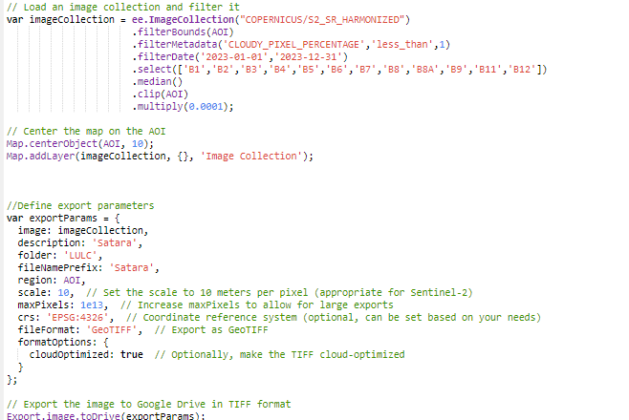

We selected the relevant spectral bands (B1, B2, B3, B4, B5, B6, B7, B8, B8A, B9, B11, and B12) and created a median composite image to minimize noise interference. The resulting Geo TIFF image, which incorporated all selected bands, was subsequently exported for further analysis.

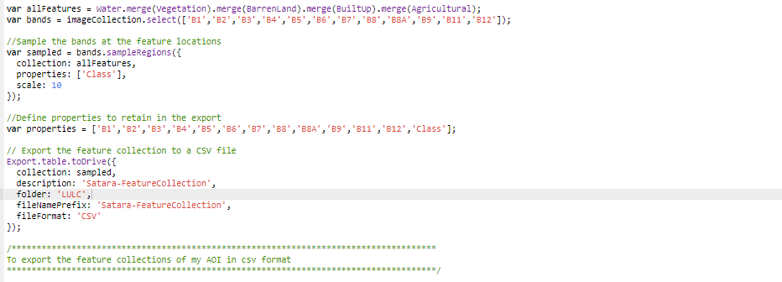

## 3.2. Support Vector Models

### 3.2.1. SVM with Grid Search

Grid Search is a brute-force search method used to explore a predefined hyperparameter space. In SVM, the key hyperparameters are the regularization parameter C, kernel type, and the kernel coefficient gamma. The parameter grid is defined in advance, and Grid Search exhaustively tries all possible combinations to find the best parameters. The GridSearchCV function is used to perform the search:

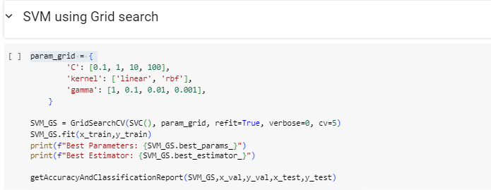

### 3.2.2. SVM with Random Search

Unlike Grid Search, Random Search explores the hyperparameter space more efficiently by randomly sampling from a specified distribution. This method is especially useful when the parameter space is large, as it allows a broader exploration within a limited number of iterations. Using RandomizedSearchCV, 100 random combinations of these parameters are tested. The Random Search approach tends to be faster than Grid Search while maintaining high accuracy. The best parameters are used to train the model, which is then validated on both validation and test sets.

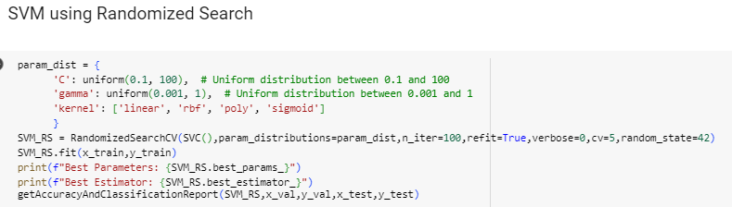

### 3.2.3. SVM Bayesian Search

Bayesian Optimization is a more sophisticated hyperparameter tuning technique that iteratively improves the search process by learning from previous results. For SVM, the search focuses on the most promising areas of the hyperparameter space, based on probabilistic models. Bayesian Search often finds better hyperparameters with fewer iterations than Grid or Random Search. Bayesian Search intelligently selects the next set of parameters to test, based on the performance of previous configurations. This method often converges to the optimal solution more quickly than traditional search methods.

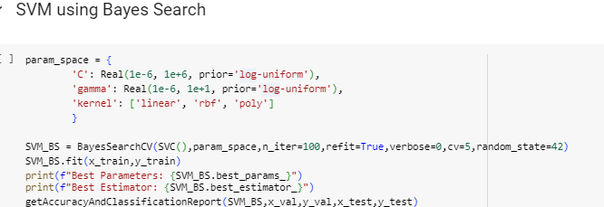

## 3.3. Random Forest

### 3.3.1. Random Forest using Grid Search

Grid Search is a traditional method that evaluates a model by exhaustively searching over a specified parameter grid. For Random Forest, important hyperparameters to optimize include the number of trees (n_estimators), the maximum depth of trees (max_depth), the minimum number of samples to split (min_samples_split), and the minimum number of samples at the leaf node (min_samples_leaf). The model is then trained using GridSearchCV.

This process exhaustively evaluates all combinations of the parameters using 5-fold cross-validation (cv=5) to identify the best configuration. After tuning, the model is retrained with the optimal parameters and tested on the validation and test datasets.

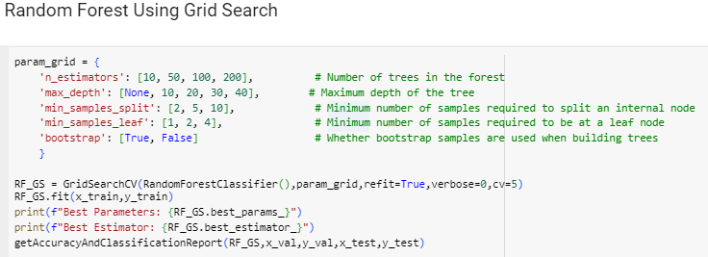

### 3.3.2 Random Forest using Random Search

Random Search improves the efficiency of hyperparameter tuning by randomly sampling from the parameter distribution rather than testing every possible combination. This allows for a wider exploration of the hyperparameter space in fewer iterations, making it useful when dealing with large datasets or numerous hyperparameters.

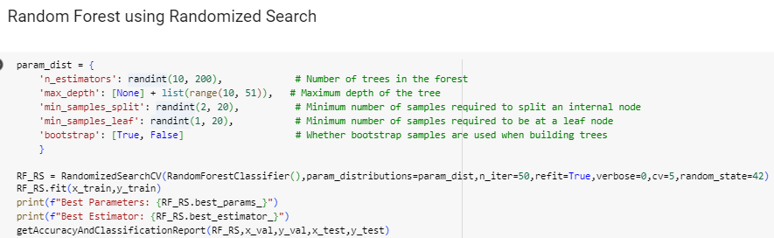

### 3.3.3. Random Forest using Bayes Search

Bayesian Optimization, a more advanced search method, evaluates the performance of the model and selects the next set of hyperparameters based on past performance, prioritizing regions of the parameter space that are more likely to improve the model. This intelligent approach to hyperparameter tuning often yields better results with fewer iterations.

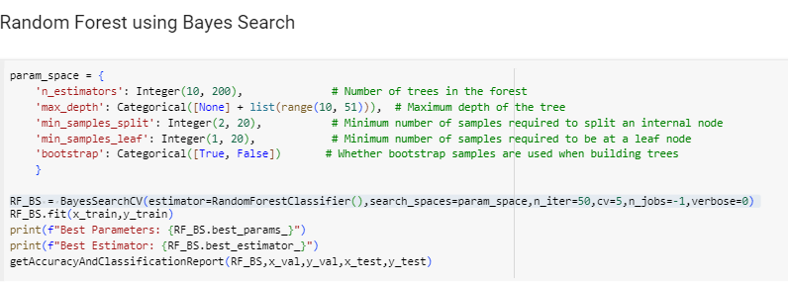

## 3.4 Artificial Neural Network (ANN)

Artificial Neural Networks (ANNs) are computational models inspired by the structure and function of biological neural networks. They consist of layers of interconnected "neurons" that process and transmit information. ANNs are powerful models for capturing complex patterns and relationships in data, especially for tasks such as image classification and other high-dimensional problems.

In this section, we focus on developing and training an ANN model for land cover classification using input features derived from satellite imagery. The development process involves data scaling, label encoding, and model construction using Keras, a popular deep learning library.

### 3.4.1. Data Preprocessing

#### Standardization (Scaling): The input features (x_train, x_val, x_test) are standardized using StandardScaler, which ensures that all the features contribute equally to the training process by bringing them to the same scale (mean = 0, variance = 1).

Label Encoding: Labels (y_train, y_val, y_test) are converted from categorical format to one-hot encoded format using LabelEncoder and to_categorical. This encoding is necessary for multi-class classification, where each label is represented as a vector with 1 in the position of the correct class and 0 elsewhere.

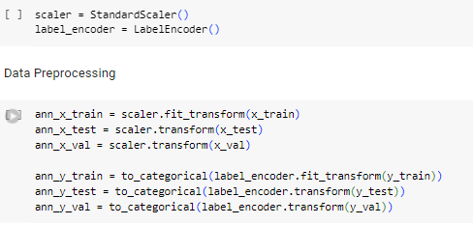

### 3.4.2 Model Definition

The ANN model is built using the Keras Sequential API. It consists of an input layer, two hidden layers, and an output layer:

* Input Layer and First Hidden Layer: The input dimension is set to the number of features in image1.count. The first hidden layer consists of 64 units with ReLU activation.
* Additional Hidden Layers: Two more hidden layers are added. The first one has 64 units, and the second one has 32 units, both using ReLU activation for non-linearity.
* Output Layer: The output layer consists of 4 units (corresponding to the number of classes) with softmax activation, which outputs the probability distribution over the classes for classification.

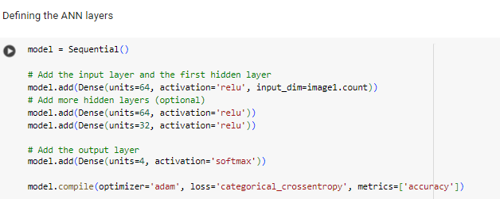

### 3.4.2. Compiling the Model

The model is compiled using the Adam optimizer, categorical_crossentropy as the loss function (suitable for multi-class classification), and accuracy as the evaluation metric.

### 3.4.3. Training the Model

The model is trained using the training data (ann_x_train, ann_y_train) and validated on the validation data (ann_x_val, ann_y_val) for 50 epochs with a batch size of 32.

### 3.4.4. Evaluating the Model

The model is evaluated on the test data (ann_x_test, ann_y_test) to assess its generalization performance. The loss and accuracy values are printed.

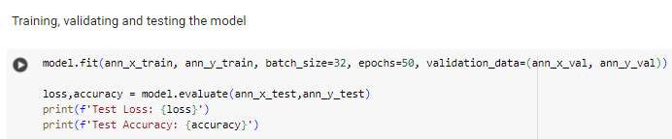

### 3.4.5. Evaluating the Model on New Data

The model is further evaluated on new data (data2). The features are scaled, and labels are encoded before evaluation. The loss and accuracy values are printed for this new dataset.

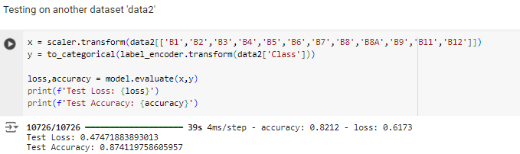

### 3.4.6. Predicting New Labels

The model makes predictions on new, unseen data (image1_dataset). After scaling the input data, predictions are generated, and the predicted class labels are determined by taking the class with the highest probability (np.argmax). These are then inverse-transformed back to their original label format using the LabelEncoder.

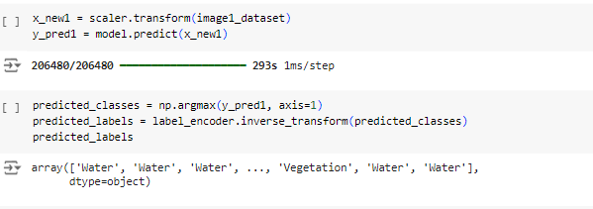

## 3.5. Model Validation and Evaluation

The validation and evaluation phase was designed to rigorously assess the robustness, accuracy, and generalizability of the developed models. This phase was crucial in ensuring that the models could reliably perform LULC classification beyond the specific training data.

### 3.5.1. Validation Techniques

Cross-validation was employed as the primary method to validate the models. By splitting the dataset into training and testing subsets, the models were evaluated across multiple folds. This approach minimized the risk of overfitting and provided a more generalized performance assessment.

### 3.5.2. Performance Metrics

The effectiveness of the SVM, RF, and ANN models was evaluated using a suite of performance metrics, including classification report, confusion matrix, accuracy, precision, recall, and the F1-score.

* A confusion matrix is generally defined as

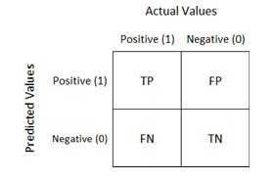

Figure 7. Confusion Matrix

**Figure 7: Sample Confusion Matrix**

* + **True Positive(TP):** Model correctly predicts the positive class (prediction and actual both are positive)
  + **True Negative(TN):** Model correctly predicts the negative class (prediction and actual both are negative)
  + **False Positive(FP):** Model gives the wrong prediction of the negative class (predicted-positive, actual-negative).
  + **False Negative(FN):** Model wrongly predicts the positive class (predictednegative, actual-postive).
* **Accuracy:** Accuracy is defined as the number of correct classifications for the whole sample size or accuracy is measured the overall correctness of the model's predictions

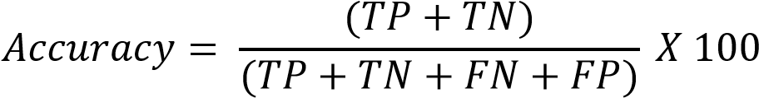

* **Precision:** Precision is defined as the ratio of correctly classified positive samples to total number of predicted classified positive sample

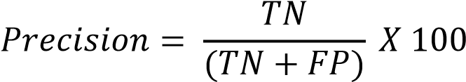

* **Recall:** Out of the total positive, what percentage is predicted positive.

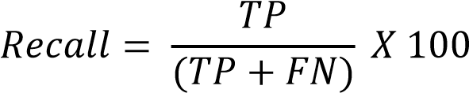

* **F1 Score:** It is the harmonic mean of precision and recall. It takes both false and positive and false negatives into account. Therefore, it performs well on an imbalanced dataset.

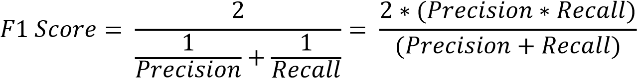

## 3.6. Generation of Classification Maps

The final phase of the project involved transforming the model predictions into visually interpretable classification maps, providing a clear representation of the land cover distribution within the study area.

### 3.6.1. Post-Processing of Model Outputs

After training, testing, and validating the models, new input data was fed into the optimized models to generate predictions of land cover classes. The predicted class labels, initially in a one-dimensional format, were reshaped into a two-dimensional array corresponding to the size of the original image. This reshaping facilitated the visualization of the classification results as a coherent image. To further refine the raw classification outputs, post-processing techniques such as smoothing and majority filtering were applied. These techniques helped eliminate any isolated misclassifications and improved the overall clarity and accuracy of the maps, ensuring they were suitable for detailed analysis and interpretation.

### 3.6.2. Map Creation and Interpretation

The processed classification results were then used to generate detailed maps, where each class label was represented by a distinct color. These maps visually depicted the distribution of different land cover types—such as Water, Built-Up areas, Vegetation, Agricultural and Barren Land— across the study area. The classification maps were carefully interpreted to derive valuable insights into the spatial patterns of land use and land cover. This interpretation provided a basis for understanding changes in the landscape over time and offered potential implications for environmental management and planning. The visually intuitive maps served as a powerful tool for communicating the results of the LULC classification to stakeholders and decision-makers.

## 3.7 Transfer Learning

Transfer learning is a powerful machine learning technique where a pre-trained model is leveraged as the starting point for a new task, typically when the available labeled data is limited. Instead of training a model from scratch, which can be time-consuming and resource-intensive, transfer learning allows us to benefit from the knowledge learned by a model on a large, general dataset and adapt it to a specific, smaller dataset or task.

The concept behind transfer learning is that the initial layers of a deep neural network (or any other model) extract general features (such as edges, shapes, or textures in image data) that can be useful across different domains. The later layers, however, are more task-specific. By retaining the knowledge embedded in the earlier layers and fine-tuning the latter layers, we can quickly and effectively retrain the model for new tasks, often achieving better performance with fewer training resources.

**Benefits of Transfer Learning**

1. Reduced Training Time: Instead of training a model from scratch, which requires vast amounts of data and computational resources, transfer learning allows us to start with a pre-trained model and fine-tune it on a smaller dataset. This significantly reduces the training time.
2. Better Performance with Limited Data: Transfer learning is particularly useful when the target task has a small dataset. The pre-trained model provides robust feature representations learned from large-scale data, helping to improve performance even with limited training examples for the new task.
3. Leveraging Pre-Trained Knowledge: By utilizing models pre-trained on large datasets (e.g., ImageNet), we can leverage powerful feature extraction capabilities, particularly in fields such as computer vision, where acquiring vast amounts of labeled data is challenging.

Transfer learning offers a highly efficient strategy for developing machine learning models, especially when labelled data is limited. By importing pre-trained models, freezing layers, and adding new task-specific layers, we can achieve better results with minimal training time. Fine-tuning further optimizes these results, allowing the model to adapt to the intricacies of the new dataset or task.

# CHAPTER 4

# CREATING A MODEL FOR REGIONAL AOI FILES EXTRACTION

## 4.1. Introduction

#### Land Use and Land Cover (LULC) classification is a very crucial component of understanding earth land surface changes, area coverage estimation and to detect objects using Remote sensing.

#### This chapter presents the method using which we have created a Basemap which displays political world map and satellite view of world through which we can mark any Area of Interest on map by drawing a polygon and getting required files for the marked area. We have also added feature for naming the file and downloading it to the user’s drive.

## 4.2. Google Earth Engine

##### Google Earth Engine is a very powerful cloud-based platform application which allows the user to do planetary-scale data analysis. It hosts a massive public data archive with tools for analyzing. Some popular datasets present inside earth engine include Sentinel-1, Sentinel-2, Landsat 5, 7, and 8.

##### Google Earth Engine provides a JavaScript API and Python API for interactive use through the Earth Engine Code editor, which is an integrated development environment accessible in the browser.

Key Features of Google Earth Engine are

1. Data Catalog: GEE contains a vast collection of publicly accessible datasets including Landsat, Sentinel, MODIS etc. It also has a good collection of climate data such as temperature, precipitation and atmospheric data
2. Cloud Computing: Users can utilize Google’s cloud infrastructure allowing users to process large amounts of data without needing high local computer resources. Users can perform large scale computations.
3. JavaScript and Python API: GEE offers Java Script and Python API for interactive use through Code editor which allows us to write scripts in environments like Jupyter Notebook or local Python scripts.
4. Image Processing and Analysis: Filtering satellite specific and dataset specific files based on cloud cover, data ranges and region of interest. It also allows to perform spectral analysis to compute vegetation Indices (NDVI), water Indices (NDWI) and urbanization indices.
5. Exporting data: Users can export processed data directly from Earth Engine to their drives GeoTIFF format for raster data, CSV files for vector data

## 4.3 Geospatial Map and ROI Selection

The project integrates Leaflet.js, turf.js and Leaflet Draw to create an interactive map where users can switch between OpenStreetMap and ARCGIS satellite map provided by ESRI. The user can draw polygons to represent Area of Interest (AOI) and calculate area of drawn polygon and download the files for marked polygon.

In the project we have displayed two layers OpenStreetMap and ARCGIS World Imagery Layes and user can toggle between the two map styles using layer control. The Openstreet map is displayed by default and is focused on Indian subcontinent.

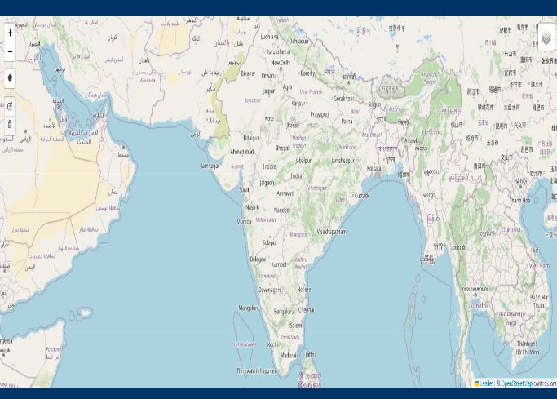

Figure 8. Open Street Map View in API

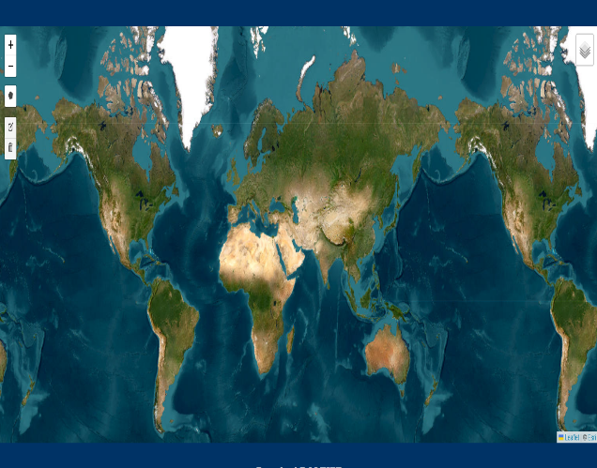

Figure 9. Satellite Map View in API

The Project utilized Leaflet Draw a plugin that allows users to draw shapes(polygons) on the map.It provides an interface for drawing and editing these shapes interactively.

The project allows user to mark AOI and swich between different map layers to get better clarity on the drawn Area surface.

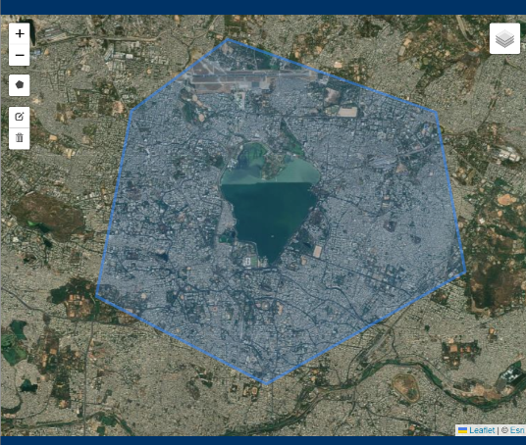

Figure 10. Draw AOI on Satellite Map

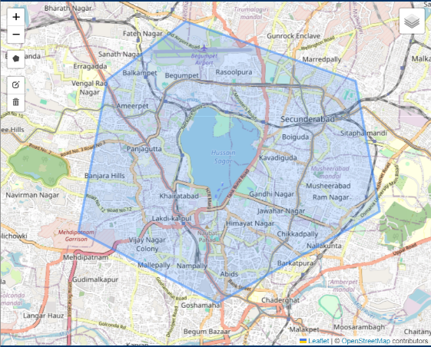

Figure 11.Draw AOI on Street Map

## 4.4 Displaying the Total Geo graphic area for Area of Interest

Using Turf.js, a geospatial analysis library we are calculating the area of drawn polygons. The area gets displayed below map to inform user about their drawn area size.

The code is waiting for the event L.DRAW.EVENT.CREATED which gets triggered whenever the user finishes drawing a polygon on the map layers. This event occurs using Leaflet’s drawing tools which allows a user to draw different shapes including polygons on a map.

The polygon that user draws is converted into GeoJSON format using the toGeoJSON() function so that coordinates of the polygon can be extracted from the GeoJSON objectto calculate Area of drawn polygon.

Turf.js is a powerful library used to perform calculations such as distance, area and intersections for geographical shapes.

The area of polygon is computed in square meters using the turf.area() function

Var area= turf.area.(geojson)

To make area easier to interpret it’s converted from square meters to square kilometers by dividing by 1,000,000.

Once the area is calculated, it’s displayed on the webpage below map in an HTML element with ID areaDisplay.

var areaElement = document.getElementById("areaDisplay");

areaElement.innerHTML = "Area of drawn polygon: " + areaInSqKm + " km²";

The code also listens for the event L.Draw.Event.Deleted when the drawn polygon are cleared from the layers of the world Map. When the polygon is deleted the displayed area is cleared, ensuring that no outdated area values remain visible on screen.

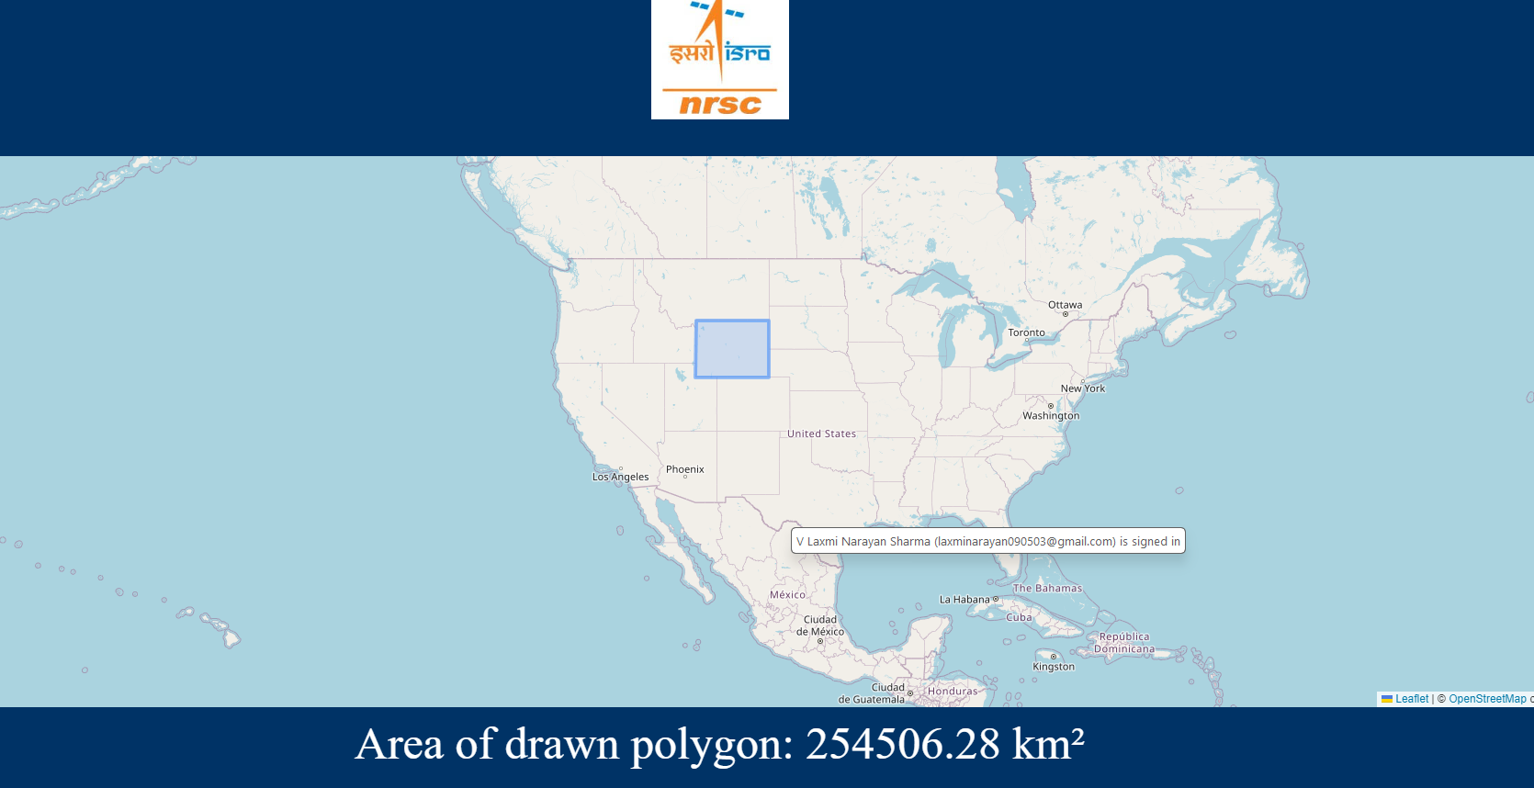

Figure 12. Total Geo Graphic Area Displayed on AOI

## 4.5 Exporting Satellite Imagery using Earth Engine

The client side interface allows the user to draw polygons and input a filename and then send the drawn polygon coordinates to backend endpoint to download the Sentinel-2 image of the drawn area and export it to google drive.

The client-side interface is built using Leaflet.js allowing users to draw polygons. After drawing the polygon the user enters a filename. Upon clicking a download button, the polygon’s coordinates and filename are sent via an HTTP POST request to the FastAPI backend.

fetch("/download/", {

method: "POST",

headers: { "Content-Type": "application/x-www-form-urlencoded" },

body: "coordinates=" + JSON.stringify(coordinates) + "&file_name=" + filename

});

## 4.6 Server-Side (FASTAPI) functionality:

**The** backend API, built with FastAPI, handles the client’s request to process and download the satellite imagery for the selected ROI.Initially the user must Authenticate and Initialize the Google Earth Engine with the project id of their google earth engine project Id.

ee.Authenticate()

ee.Initialize(project='ee-laxminarayan090503')

It’s workflow is

### 4.6.1. Receiving client request:

FastAPI receives the POST request containing the ROI coordinates and the desired name. This request is processed using the FASTAPI Form method.

@app.post("/download/")

async def download_tiff(coordinates: str = Form(...), file_name: str = Form(...)):

@app.post indicates that this function will handle POST requests made to the /download/ endpoint.

The function download_tiff is declared as async, meaning it can handle long-running processes without blocking other requests.

Coordinates: str= form(…): the coordinates parameter is to be sent in form data as it will represent the drawn polygon by the user, in GeojSON format as a string.

Fine_name: str=Form(…): the file_name to be sent by user which will be filename of drawn AOI file in drive.

### 4.6.2 Converting ROI Coordinates to Google Earth Engine Geometry:

The coordinates received from the client are converted into a format that Google Earth Engine can process. The coordinates are converted into a Polygon object.

### 4.6.3. Retrieving Satellite Imagery using GEE

The coordinates from the form data are used to create a polygon geometry in Google Earth Engine. geom = ee.Geometry.Polygon(eval(coordinates))

1. ee.ImageCollection(‘COPERNICUS/S2_SR_HARMONIZED’):this snippet is used to select Sentinel 2 sattelite imagery dataset in Google Earth Engine.
2. Filterbounds(geom):Filters the image collection to include only images that intersect with the drawn polygon(AOI).
3. filterMetadata(‘CLOUDY_PIXEL_PERCENTAGE’,’less_than’,1): Filters the image collection to include images with less than 1% cloud cover
4. filterdate(‘2023-01-01’,’2023-12-31’): Limits the collection to images captured in year 2023.
5. Select(): Selects specific bands from Sentinel-2 ['B1', 'B2', 'B3', 'B4', 'B5', 'B6', 'B7', 'B8', 'B8A', 'B9', 'B11', 'B12']

### 4.6.4. Exporting the Image to Google Drive

ee.batch.Export.image.toDrive: this command snippet exports the image to user’s drive

image=image: The image to export is one processed earlier

description=a description for export task

folder=’GEE_Exports’: the folder in the user’s google drive where the file will be saved

filenameprefix= file_name which is given by user

scale=30: the scale is in meter per scale

region=geom.getInfo()[‘coordinates’]: the coordinates of polygon are used to define region for export

fileFormat=’GEOTIFF’

task.start(): this starts the export task in earth engine background.

@app.post("/download/")

async def download_tiff(coordinates: str = Form(...), file_name: str = Form(...)):

try:

geom = ee.Geometry.Polygon(eval(coordinates)) # Parse AOI coordinates from the form

image = ee.ImageCollection('COPERNICUS/S2_SR_HARMONIZED') \

.filterBounds(geom) \

.filterMetadata('CLOUDY_PIXEL_PERCENTAGE', 'less_than', 1) \

.filterDate('2023-01-01', '2023-12-31') \

.select(['B1', 'B2', 'B3', 'B4', 'B5', 'B6', 'B7', 'B8', 'B8A', 'B9', 'B11', 'B12']) \

.median()\

.clip(geom)\

.multiply(0.0001)

unique_file_name = f"{file_name}_{randint(1000, 9999)}" # Append random number for unique filename

# Export image to Google Drive

task = ee.batch.Export.image.toDrive(

image=image,

description=unique_file_name,

folder='LULC',

fileNamePrefix=unique_file_name, # Use the unique file name

scale=30,

region=geom.getInfo()['coordinates'],

fileFormat='GeoTIFF'

)

task.start()

# Return success response

return {"status": "Export started", "file_name": unique_file_name}

except Exception as e:

logger.error(f"Error during download: {e}")

raise HTTPException(status_code=500, detail=f"Download failed: {e}")

# CHAPTER 5

# CREATION OF API FOR LULC CLASSIFICATION

Land Use and Land Cover Classification is a very important factor in analyzing and monitoring the Earth’s surface. By analyzing satellite imagery, we can identify various land cover types, including various kings of agricultural, forest vegetation and barren lands. The project utilizes various machine learning models which have opened new possibilities for large-scale land cover classification. We have utilized our pre-trained models from the google collab with a focus to interact with the user through file upload and region selection on world map.

The API is designed to run on any local machine with Python 3.9 or higher versions along with latest upgraded pip installer. The API form allows users to upload a .tiff file , select a classification methods and submit to get displayed the classified image of landcover along with a download-tiff button to download the classified land-cover .tiff format file which user can download and store in his local device.

## 5.1 API Objectives and Overview

The LULC classification API is designed to run on a local machine, with FastAPI serving as the framework. The API allows users to upload a TIFF file (satellite imagery), select a classification method, and download the classified land-cover image in .tiff format. The API creates .png and also .tiff format for the classified land cover.

## 5.2 Technologies Used

**1.FastAPI:** FastAPI is a modern, high-performance web framework used for building Apis with Python. It is used for building fast and scalable web applications by supporting asynchronous programming in this project. It allows us to handle file uploads, manage forms and serve HTTP responses.

Endpoint routes such as /classify/ and /download/ are used to process image files, apply classification and download desired results.

**2.File, UploadFile, Form, Request, HTTPException (FastAPI Components):**

File and UploadFile : Handles file upload through API

Form: Capture form data submitted by user

Request: used to access request-related information

HTTPException: Used for Error handling when requests fail

1. **HTMLResponse, FileResponse:** Sends HTML Pagesas Response and allows user to download files
2. **Jinja2Templates:** Jinja2 is a templating engine used o generate HTML pages dynamically.
3. **Static Files:** Static Files such as images, CSS and JavaScript are served from the users /static directory.
4. **Numpy**: Foundational library for numerical computing in Python.
5. **Pandas**: Provides provides data structures like DataFrames that simplify handling tabular data.
6. **Pickle**: Serialization library which is used to save and load a pre-trained models for classifying land cover.The models are serialed to .pkl files, which can be quickly loaded into memory.
7. **Logging**: logging module is used to track the application's execution by recording important events, such as file uploads, errors, or the completion of classification processes.
8. **Rasterio:** library for reading and writing geospatial raster data such as satellite imagery. In project it reads TIFF files, extracts image bands and writes new classified images as GeoTIFFs.
9. **Rasterio.transform**: The from_origin function is used to define the spatial transformation for new GeoTIFF files (e.g., classified images) by setting their geographical reference from the origin point (top-left corner) and pixel size.
10. **Matplotlib**: Data Visualization Library used for plotting and visualizing images and maps.
11. **EarthPy**:Geospatial Visualization Library used for working with spatial data, and it’s plot_rgb function is used to render RGB images from satellite data.
12. **Google Earth Engine**: Cloud based Geo Spatial Analysis Platform
13. **Shutil**: It simplifies file operations such as copying, moving, and managing directories.

## 5.3 Code Initialization and logging

**Main Code (main.py)**

5.3.1. Importing Libraries:

The necessary libraries are imported at he beginning. This includes FastAPI, HTML responses and file uploads and all above mentioned technologies in the starting of this chapter.Google Earth Engine is initialized here to enable remote sensing operations.

**from fastapi import FastAPI, File, UploadFile, Form, Request, HTTPException**

**from fastapi.responses import HTMLResponse, FileResponse**

**from fastapi.staticfiles import StaticFiles**

**from fastapi.templating import Jinja2Templates**

**import geemap**

**import ee**

**import os**

**import shutil**

**import numpy as np**

**import pandas as pd**

**import rasterio**

**import pickle**

**import matplotlib.pyplot as plt**

**import logging**

**from random import randint**

**from rasterio.transform import from_origin**

**import earthpy.plot as ep # Make sure this line is included for earthpy**

**from sklearn.preprocessing import StandardScaler,LabelEncoder**

c

### 5.3.2.Logging & Earth Engine Authentication and Initialization:

Configures a basic logging system to log events such as erroes or file uploads then we authenticate and initialize the connection to Earth Engine. This is essential for accessing satellite imagery and geospatial data stored in GEE.The project utilizes GEE to get required TIFF files for marked polygons.

logging.basicConfig(level=logging.INFO)

logger = logging.getLogger(__name__)

# Earth Engine initialization

ee.Authenticate()

ee.Initialize(project='ee-laxminarayan090503')

1. **FastAPI APP Initialization**: Initializes the FastAPI application. This app instance will be used to define routes and handle incoming requests.
2. **Static Files and Templating Setup:**Serves static files such as CSS, JS and images from the static directory.

**Templates:** use Jinja2 Templates stored in the templates directory to dynamically generate HTML pages from the web Interface.

### 5.3.3.File Upload Route:

This ensures that a directory folder names uploaded_files is available to store uploaded TIFF images by the user. The variable uploaded_files_dir holds the name of the directory which is set to “uploaded_files”.

## 5.4 Functions used in Project

1. **Tiff_to_csv(image):** Takes a TIFF image as input and converts it into a structured pandas DataFrame for image creation and for classifying image by machine learning models. It creates a pandas DataFrame where each columns represents one of the image’s bands, and each row contains the pixel value for each band at a specific location. The raster image is opened with rasterio library.

bands = ['B1', 'B2', 'B3', 'B4', 'B5', 'B6', 'B7', 'B8', 'B8A', 'B9', 'B11', 'B12']

Image Reading: reading the pixel values for all band in TIFF file and using flatten() converts the 2D pixel array into 1D array for easier understanding.

Then using numpy array convert list of 1D array into a 2D Numpy array, then transpose it to make each column represent a band.Then we create a DataFrame with rows as pixel and columns represent as bands.

The function than returns the created dataset

def tiff_to_csv(image):

bands = ['B1', 'B2', 'B3', 'B4', 'B5', 'B6', 'B7', 'B8', 'B8A', 'B9', 'B11', 'B12']

data = [image.read(i + 1).flatten() for i in range(image.count)]

dataset = pd.DataFrame(np.array(data).T, columns=bands)

dataset.fillna(0.0001, inplace=True)

return dataset

1. **plot_classified_map(image, labels, image_shape, title, temp_number, original_image, save_di='static'):** The Function is designed to visualize and save classified land cover maps, as well as RGB images and save them in PNG and TIFF formats.

**Parameters:**

1. **image:** A raster image containing multispectral data
2. **labels:** A 1D array of labels representing classified land cover types for each pixel generated using pre-trained models.
3. **Image_shape:** The shape (height and width) of the image, used to reshape the classified labels into 2D format.
4. **Title:** title to be displayed on classified map plot
5. **Temp_number:** A unique identifier to generate unique filenames for saved images
6. **Original_image:** The original raster image used to retrieve image metadata (such as spatial resolution and coordinate reference system).
7. **Save_dir:** the directory where the output files will be saved (default is ‘static’)

**Color Map:** The color_map directory defines specific RGB values for each land cover class.

1. Water: Light blue.
2. BuiltUp: Red.
3. Vegetation: Green.
4. BarrenLand: Orange.
5. Agricultural: Yellow.

Subplot creation by creating a figure with 3 subplots in a row with a size of 20 * 7 inches.

fig, axs = plt.subplots(1, 3, figsize=(20, 7))

**RGB Images with Bands 4,3,2:**

Reading the pixel values for bands 4,3,and 2(Red, Green and Blue), these bands are stacked together into a 3D array using np.stack(). Ep.plot_rgb() is used to display the RGB image using these bands on first subplot (axs[0]) and the axis is turned off for cleaner visualization.

**FCC Image with Bands 8,4,3**

Reading the pixel values for bands 8,4,and 3, these bands are stacked together into a 3D array using np.stack(). Ep.plot_rgb() is used to display the RGB image using these bands on first subplot (axs[1]) and the axis is turned off for cleaner visualization.

**Creating Classified Land Cover Map and Calculating percentage of each class**

* Classifying land Cover: Reshapes the flat array of classification labels into a 2D format based on the original image dimensions.
* Creating RGB Array: Converting the classified labels into RGB color representation using color_map dictionary to map each unique label value to it’s corresponding RGB color, defaulting to black for any value not found in the map
* Calculating Class Percentages: : Finds unique land cover labels and their respective counts in the land_cover array.Then calculating total nuber of pixels in the land cover classification. We can then calculate the percentage of each class based on the total pixel count for each class.
* We then have created a legend for each class in land cover classes along with their respective color used for creating classified map

**Saving Files in Directory and Creating Classified TIFF File**:

The variable temp_number is used to create unique filenames. The paths for saving the images are constructed by joining a specified directory (save_dir) with the respective filenames. The classified map is saved as a PNG file using Matplotlib's savefig function. The bbox_inches='tight' parameter ensures that the saved figure includes all elements tightly, and pad_inches=0.1 adds a small padding around the figure.Then we save the RGB array representation of the classified image as a separate PNG file using imsave, which is useful for visualizing the classified land cover.

**Creating TIFF File**

The height and width of the RGB array are extracted for creating the TIFF file.A transform object is created using from_origin, which establishes the spatial reference for the TIFF file based on the original image's bounds and resolution.A new TIFF file is created using rasterio.open in write mode ('w'). The file is configured to store three RGB bands and includes the specified height, width, data type, coordinate reference system (CRS), and transform.Each band of the RGB array is written to the corresponding band in the TIFF file using dst.write.

The function returns the paths of the three saved files, allowing the caller to know where to find the results.

def plot_classified_map(image, labels, image_shape, title, temp_number, original_image, save_dir='static'):

color_map = {

'Water': [0.53, 0.81, 0.98],

'BuiltUp': [1, 0, 0],

'Vegetation': [0.13, 0.55, 0.13],

'BarrenLand': [1, 0.65, 0],

'Agricultural': [1, 1, 0]

}

fig, axs = plt.subplots(1, 3, figsize=(20, 7))

# RGB Image Bands 4, 3, 2

image_vis_432 = np.stack([image.read(b) for b in [4, 3, 2]])

ep.plot_rgb(image_vis_432, ax=axs[0], stretch=True)

axs[0].set_title('Image (Bands 4, 3, 2)')

axs[0].axis('off')

# RGB Image Bands 8, 4, 3

image_vis_843 = np.stack([image.read(b) for b in [8, 4, 3]])

ep.plot_rgb(image_vis_843, ax=axs[1], stretch=True)

axs[1].set_title('Image (Bands 8, 4, 3)')

axs[1].axis('off')

# Classified land cover map

# Classified land cover map

land_cover = labels.reshape(image_shape[0], image_shape[1])

rgb_array = np.array([[color_map.get(value, [0, 0, 0]) for value in row] for row in land_cover])

axs[2].imshow(rgb_array, aspect='equal')

unique, counts = np.unique(land_cover, return_counts=True)

total_pixels = land_cover.size

percentages = {label: (count / total_pixels) * 100 for label, count in zip(unique, counts)}

colors = [color_map[key] for key in color_map]

labels = [f"{key}: {percentages.get(key, 0):.2f}%" for key in color_map]

patches = [plt.plot([], [], marker="s", ms=10, ls="", mec=None, color=colors[i],

label=labels[i])[0] for i in range(len(labels))]

# Add the legend with title 'Land Cover Classes'

axs[2].legend(handles=patches, bbox_to_anchor=(1, 1), loc="upper left", frameon=False, title="Land Cover Classes")

axs[2].set_title(title)

classified_map_filename = f'classified_map_{temp_number}.png'

new_classified_image_filename = f'new-classified_{temp_number}.png'

classified_tiff_filename = f'new-classified_{temp_number}.tiff'

classified_map_path = os.path.join(save_dir, classified_map_filename)

new_classified_image_path = os.path.join(save_dir, new_classified_image_filename)

classified_tiff_path = os.path.join(save_dir, classified_tiff_filename)

# Save classified map as 'classified_map_XXX.png'

plt.savefig(classified_map_path, bbox_inches='tight', pad_inches=0.1)

# Save the classified image separately as 'new-classified_XXX.png'

plt.imsave(new_classified_image_path, rgb_array)

# Create TIFF file with the RGB array

height, width, _ = rgb_array.shape

transform = from_origin(original_image.bounds.left, original_image.bounds.top, original_image.res[0], original_image.res[1])

with rasterio.open(

classified_tiff_path,

'w',

driver='GTiff',

height=height,

width=width,

count=3, # RGB bands

dtype=rgb_array.dtype,

crs=original_image.crs,

transform=transform

) as dst:

# Write each band (R, G, B) to the TIFF file

dst.write(rgb_array[:, :, 0], 1) # Red band

dst.write(rgb_array[:, :, 1], 2) # Green band

dst.write(rgb_array[:, :, 2], 3) # Blue band

plt.close(fig)

logger.info(f"Classified map saved to {classified_map_path}, new classified image saved as {new_classified_image_path}, and TIFF saved as {classified_tiff_path}")

return classified_map_path, new_classified_image_path, classified_tiff_path # Return 3 paths

## 5.5 Routes and Endpoint

### A .@app.get("/", response_class=HTMLResponse)

### Async def main(request: Request):

We have specified that the folowing main function is associated with the GET HTTP method for the root path (“/”).The response will be of type HTML.The main function is defined as an asynchronous function, allowing it to handle requests without blocking the server, The request parameter is of type request, which provides information about the incoming HTTP request.

**return templates.TemplateResponse("index.html", {"request": request, "image_url": None})**

The endpoint renders the HTML template names “index.html” from the templates objects.This endpoint serves as the main page of the FastAPI application by rendering the index.html template without image url.

# FastAPI routes

@app.get("/", response_class=HTMLResponse)

async def main(request: Request):

return templates.TemplateResponse("index.html", {"request": request, "image_url": None})

### B. @app.post("/classify/")

### async def classify_image(request: Request, file: UploadFile = File(...), method: str = Form(...)):

The FastAPI route defines an endpoint (“/classify/”) that handles the classification of TIFF images using the specified Classification method.

@app.post(“/Classify”): This decorator indictes that the function classify_image will handle POST Requests sent to /classify/ URL.

**Parameters:**

* request: Request: The incoming request object, which allows access to request data and context.
* file: UploadFile = File(...): This parameter expects a file upload from the client. The UploadFile type is used for handling file uploads, and File(...) indicates that this parameter is required.
* method: str = Form(...): This parameter captures the classification method selected in the form submitted by the user. The Form(...) indicates that it should be sent as form data.

### File Handling

* file_name: Retrieves the original name of the uploaded file.
* temp_number: Generates a random integer between 1 and 1000 to create a unique temporary filename for the uploaded image.
* temp_file_path: Constructs the file path for saving the temporary TIFF image in a designated directory (uploaded_files_dir).
* The with open(...) statement opens the temporary file in write-binary mode ("wb") and copies the contents of the uploaded file into this temporary file using shutil.copyfileobj(), which is efficient for file copying.

**Image Processing**

* Image Opening: The uploaded TIFF image is opened using rasterio.open().
* tiff_to_csv(image): This function (not shown in your code) presumably processes the TIFF image and converts it to a suitable format (like a CSV or a feature matrix) for classification.
* image_shape: Retrieves the shape (dimensions) of the first band of the image, which will be used later for visualization.
* Error Handling: If an error occurs during the image processing, it logs the error and raises an HTTPException with a 400 status code, indicating a bad request.

### Model Loading

* model_file: Constructs the path to the pre-trained model file based on the selected classification method.
* Model Loading: Checks if the model file exists. If it does, it opens the file and loads the model using pickle.load().
* Logging: Logs information about the loaded model.
* Error Handling: If the model file does not exist, it logs an error and returns an HTML response, indicating that the model was not found, and setting image_url to None.

**Prediction and Classification**

The function uses the loaded classifier (clf) to predict labels for the processed image dataset. The output (labels) corresponds to the classification results for the image.

**Image Saving and Path Retrieval**

The function then calls the plot_classified_map() function (not provided in your code) to generate visualizations of the classified map, saving the resulting images and TIFF file. The function returns the paths of the saved files.

**Returning the Response**

return templates.TemplateResponse("index.html", {

"request": request,

"file_name": file_name,

"method": method,

"image_url": image_url,

"new_classified_url": new_classified_url,

"classified_tiff_url": classified_tiff_url

})

Returns an HTML response rendering the index.html template, passing various context variables:

* file_name: The name of the uploaded file.
* method: The classification method used.
* image_url: The URL of the saved classified map image.
* new_classified_url: The URL of the newly classified image.
* classified_tiff_url: The URL of the classified TIFF file.

@app.post("/classify/")

async def classify_image(request: Request, file: UploadFile = File(...), method: str = Form(...)):

file_name = file.filename # Get the file name

temp_number = str(randint(1, 1000)) # Generate a new random number for each classification

temp_file_path = os.path.join(uploaded_files_dir, f"temp_image_{temp_number}.tif")

with open(temp_file_path, "wb") as buffer:

shutil.copyfileobj(file.file, buffer)

# Open and process TIFF image

try:

image = rasterio.open(temp_file_path)

image_dataset = tiff_to_csv(image)

image_shape = image.read(1).shape

except Exception as e:

logger.error(f"Error processing TIFF image: {e}")

raise HTTPException(status_code=400, detail="Error processing TIFF image")

# Load pre-trained model

if method == "ANN":

# Load ANN model, scaler, and label encoder

model_file = f"classification_methods/ANN_model-3.pkl"

scaler_file = f"classification_methods/Scaler_ANN_model-3.pkl"

label_encoder_file=f"classification_methods/label_encoder-3.pkl"

if os.path.exists(model_file) and os.path.exists(scaler_file):

with open(model_file, 'rb') as model_f:

ANN_clf = pickle.load(model_f)

# Load scaler

with open(scaler_file, 'rb') as scaler_f:

ANN_scaler = pickle.load(scaler_f)

with open(label_encoder_file, 'rb') as label_f:

label_encoder = pickle.load(label_f)

# Transform and predict

x_new1 = ANN_scaler.transform(image_dataset)

y_pred1 = ANN_clf.predict(x_new1)

predicted_classes = np.argmax(y_pred1, axis=1)

else:

logger.error(f"Model, scaler, or label encoder file not found.")

return templates.TemplateResponse("index.html", {

"request": request,

"image_url": None,

"error": "Model, scaler, or label encoder file not found."

})

labels = label_encoder.inverse_transform(predicted_classes)

saved_image_path, new_classified_image_path, classified_tiff_path = plot_classified_map(image, labels, image_shape, "Classified Land Cover Map", temp_number=temp_number, original_image=image)

# Get file names to send back to the frontend

image_url = os.path.basename(saved_image_path)

new_classified_url = os.path.basename(new_classified_image_path)

classified_tiff_url = os.path.basename(classified_tiff_path)

# Return response with URLs for images and TIFF file

return templates.TemplateResponse("index.html", {

"request": request,

"file_name": file_name,

"method": method,

"image_url": image_url,

"new_classified_url": new_classified_url,

"classified_tiff_url": classified_tiff_url

})

### C. @app.get("/static/{filename}")

### async def download_classified_tiff(filename: str):

**Parameters:**

* tiff_path: The full path to the file to be served.
* media_type='image/tiff': This specifies the MIME type of the file being served, indicating that the content type is a TIFF image. This helps the client (like a web browser) understand how to handle the file.
* filename=filename: This specifies the name of the file as it should appear when downloaded by the client. This could be different from the actual file path if needed.

**Endpoint Definition**

* @app.get("/static/{filename}"): This decorator indicates that the download_classified_tiff function will handle GET requests sent to the /static/{filename} URL. The {filename} part is a path parameter that allows users to specify the name of the TIFF file they wish to download.
* async def download_classified_tiff(filename: str): The function is defined as asynchronous (async) to handle concurrent requests more efficiently. The parameter filename captures the name of the file that the user wants to download.

**File Path Construction:**

tiff_path: This variable constructs the full path to the requested TIFF file by concatenating the base directory (static/images/) with the specified filename. This means that all the TIFF files should be located within the static/images directory relative to where the FastAPI application is running.

**File Existence Check:**

os.path.exists(tiff_path): This checks whether the specified file exists in the filesystem. It returns True if the file is found at the given path, and False otherwise.

**File Response**

return FileResponse(...): If the file exists, the function returns a FileResponse, which is a special FastAPI response type used to serve files directly to the client.

**Error Handling**

File Not Found: If the specified file does not exist (i.e., os.path.exists(tiff_path) returns False), the function returns a JSON response indicating that the file was not found. This response is a simple dictionary with an error key and an appropriate message, which will be automatically converted to JSON format by FastAPI.

@app.get("/static/{filename}")

async def download_classified_tiff(filename: str):

tiff_path = f"static/images/{filename}" # Adjust path here

if os.path.exists(tiff_path):

return FileResponse(tiff_path, media_type='image/tiff', filename=filename)

return {"error": "File not found"}

# CHAPTER 6

# RESULTS AND ANALYSIS

This chapter presents a detailed analysis of the results obtained from various machine learning and deep learning models used for Land Use and Land Cover classification. The API generated classified maps are available in different formats of PNG and TIFF.

## 6.1 Overview of Models

The LULC Classification models were created using three different machine learning models- Support Vector Machine (SVM), Random Forest (RF), and Artificial Neural Network (ANN). We also applied three different Hyper Parameter tunning methods – Grid Search, Random Search and Naïve Bayes search on the three learning methods.

The models were trained and tested on a labelled datasets generated from Google Earth Engine which includes the following land cover classes: Water, built Up areas, Vegetation, Barren Land and Agricultural lands. The accuracy and effectiveness of each model was evaluated based on testing data and it’s ability to distinguish between different classes.

### Support Vector Machines (SVM):

A Support Vector Machine (SVM) is a supervised machine learning algorithm used for both classification and regression tasks. While it can be applied to regression problems, SVM is best suited for classification tasks. The primary objective of the SVM algorithm is to identify the optimal hyperplane in an N-dimensional space that can effectively separate data points into different classes in the feature space. The algorithm ensures that the margin between the closest points of different classes, known as support vectors, is maximized.

The dimension of the hyperplane depends on the number of features. For instance, if there are two input features, the hyperplane is simply a line, and if there are three input features, the hyperplane becomes a 2-D plane. As the number of features increases beyond three, the complexity of visualizing the hyperplane also increases.

### Random Forest (RF):

Random Forest is a popular machine learning algorithm that belongs to the supervised learning technique. It can be used for both Classification and Regression problems in ML. It is based on the concept of **ensemble learning,** which is a process of combining multiple classifiers to solve a complex problem and to improve the performance of the model.

As the name suggests, ***"Random Forest is a classifier that contains a number of decision trees on various subsets of the given dataset and takes the average to improve the predictive accuracy of that dataset."*** Instead of relying on one decision tree, the random forest takes the prediction from each tree and based on the majority votes of predictions, and it predicts the final output.

**The greater number of trees in the forest leads to higher accuracy and prevents the problem of overfitting.**

### Artificial Neural Network

In machine learning, a **neural network** (also **artificial neural network** or **neural net**, abbreviated **ANN** or **NN**) is a model inspired by the structure and function of biological neural networks in animal brains.

An ANN consists of connected units or nodes called *artificial neurons*, which loosely model the neurons in the brain. These are connected by *edges*, which model the synapses in the brain. Each artificial neuron receives signals from connected neurons, then processes them and sends a signal to other connected neurons. The "signal" is a real number, and the output of each neuron is computed by some non-linear function of the sum of its inputs, called the *activation function*. The strength of the signal at each connection is determined by a *weight*, which adjusts during the learning process.

Typically, neurons are aggregated into layers. Different layers may perform different transformations on their inputs. Signals travel from the first layer (the *input layer*) to the last layer (the *output layer*), possibly passing through multiple intermediate layers (*hidden layers*). A network is typically called a deep neural network if it has at least two hidden layers.

## 6.2 Hyper Parameter Tuning

Hyperparametertuning is the process of selecting the best set ofhyperparameters for a machine learning model. Hyperparameters are parameters whose values are set before the training process, such as the number of trees in a Random Forest, the learning rate in a neural network, or the regularization parameter in a Support Vector Machine (SVM). These hyperparameters influence the training process and have a significant impact on model performance.

Hyperparameter tuning aims to find the optimal set of hyperparameters that result in the best possible performance of the model on unseen data. It usually involves an iterative process where different hyperparameter combinations are tested, and their results are evaluated using a validation set or through cross-validation.

There are various strategies for hyperparameter tuning, with Grid Search, Random Search, and Bayesian Optimization (including Naive Bayes Search) being the most common methods

1. **Grid Search**

Grid Search is a systematic and exhaustive approach to hyperparameter tuning. In grid search, you specify a grid of possible hyperparameter values and the model is trained and evaluated on each combination of these hyperparameters. The goal is to find the combination that provides the highest performance.

How It Works:

Define a range of hyperparameter values to explore.

Grid search will create all possible combinations of these hyperparameters.

Each combination is evaluated (usually through cross-validation), and the one yielding the best performance is selected.

1. **Random Search**

Random Search is a more efficient alternative to Grid Search. Instead of evaluating all possible combinations of hyperparameters, it randomly selects combinations from the specified hyperparameter space and evaluates them. The idea is that sampling random combinations may lead to good results without the computational cost of exhaustively searching all possibilities.

How It Works:

Define a range of hyperparameter values (like Grid Search).

Instead of evaluating all combinations, Random Search randomly picks a specified number of combinations to evaluate.

The best-performing set of hyperparameters from the random samples is selected.

1. **Naïve Bayes Search**

Bayesian Optimization is a probabilistic model-based optimization method for hyperparameter tuning. It builds a probabilistic model (such as a Gaussian process) of the objective function (e.g., model performance) and uses this model to select the most promising hyperparameters to evaluate next.

A variant of Bayesian Optimization, known as Naive Bayes Search, is a less computationally expensive method compared to full Bayesian optimization. It focuses on incorporating probabilistic reasoning to infer the best hyperparameter values based on previous evaluations.

How It Works:

The process begins by evaluating a set of hyperparameters and calculating their performance.

Using the results from the initial evaluations, the algorithm builds a model (often Gaussian process) to predict how well unseen hyperparameter combinations might perform.

The model identifies the next set of hyperparameters to evaluate, balancing between exploring new areas of the hyperparameter space and exploiting known good areas.

The process continues iteratively, with the algorithm updating its model after each new evaluation and refining its predictions.

|  |  |  |  |  |  |  |  |  |
| --- | --- | --- | --- | --- | --- | --- | --- | --- |
| **Models** |  | **Validation** | |  |  | **Test** | |  |
| **Accuracy** | **F1** | **Precision** | **Recall** | **Accuracy** | **F1** | **Precision** | **Recall** |
| SVM_GS | 0.969 | 0.969 | 0.970 | 0.969 | 0.967 | 0.969 | 0.970 | 0.969 |
| SVM_RS | 0.971 | 0.971 | 0.972 | 0.971 | 0.967 | 0.971 | 0.972 | 0.971 |
| SVM_BS | 0.965 | 0.965 | 0.965 | 0.965 | 0.963 | 0.965 | 0.965 | 0.965 |
| RF_GS | 0.974 | 0.974 | 0.975 | 0.974 | 0.974 | 0.974 | 0.975 | 0.974 |
| RF_RS | 0.974 | 0.971 | 0.972 | 0.971 | 0.974 | 0.971 | 0.972 | 0.971 |
| RF_BS | 0.971 | 0.971 | 0.972 | 0.971 | 0.971 | 0.971 | 0.972 | 0.971 |
| ANN | 0.965 | 0.911 | 0.928 | 0.903 | 0.967 | 0.911 | 0.931 | 0.909 |

**Table 2. Accuracy Assessment of Different Models**

## 6.3. Accuracy Assessment

The accuracy of each model was rigorously assessed using several metrics: accuracy, precision, recall, and F1-score. These metrics provided a comprehensive understanding of each model's performance in classifying the different LULC types.

• SVM: The SVM model demonstrated balanced performance across all classes. It achieved high precision in classifying Vegetation, which contributed to its strong overall accuracy. However, its performance was slightly lower in classes with overlapping spectral characteristics.

• Random Forest: The Random Forest model achieved the highest recall for the Water class, indicating its effectiveness in correctly identifying all Water pixels. The model's performance was consistent across the dataset, making it a reliable choice for LULC classification tasks.

• ANN: The ANN model outperformed the other models in terms of overall accuracy and F1-score. Its ability to balance precision and recall across all classes contributed to its superior performance, particularly in challenging classification scenarios.

Summary: Each model's accuracy was evaluated using precision, recall, and F1-score, with ANN emerging as the top performer, followed by RF and SVM. Cross-validation confirmed the robustness of these results.

## 6.4. CLASSIFIED LAND COVER MAPS

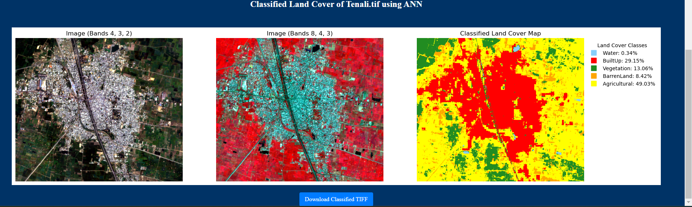

Figure 13 Tenali Classified Map using Artificial Neural Network

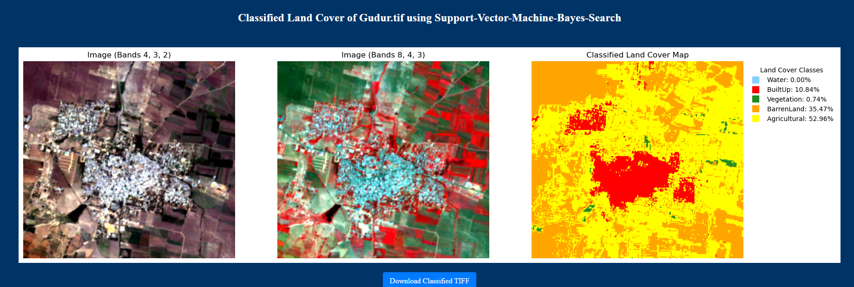

Figure 14 Gudur Classified Map using Support Vector Machine Bayes Search Classification

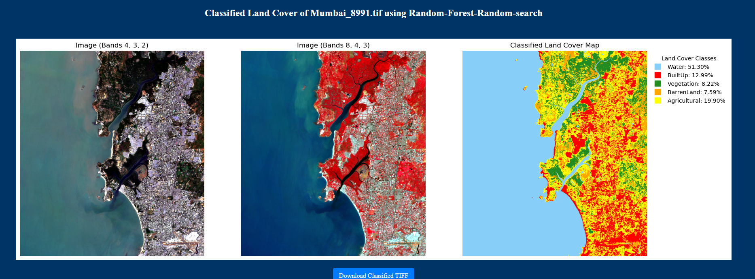

Figure 15 Mumbai Classified Map using Random Forest Random Search Classification

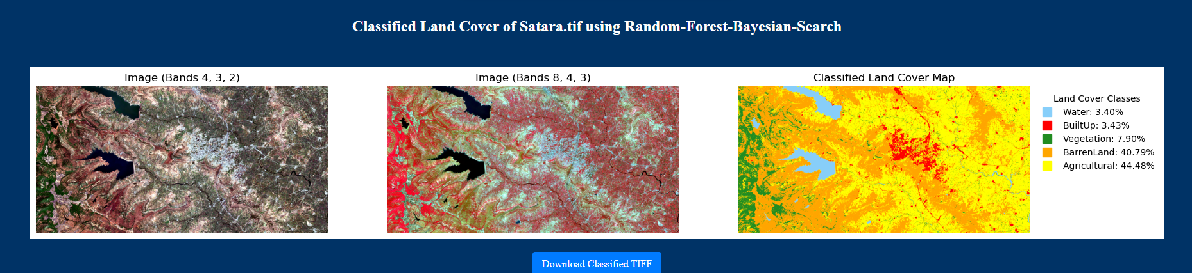

Figure 16 Satara Classified Map using Random Forest Bayesian Search Classification

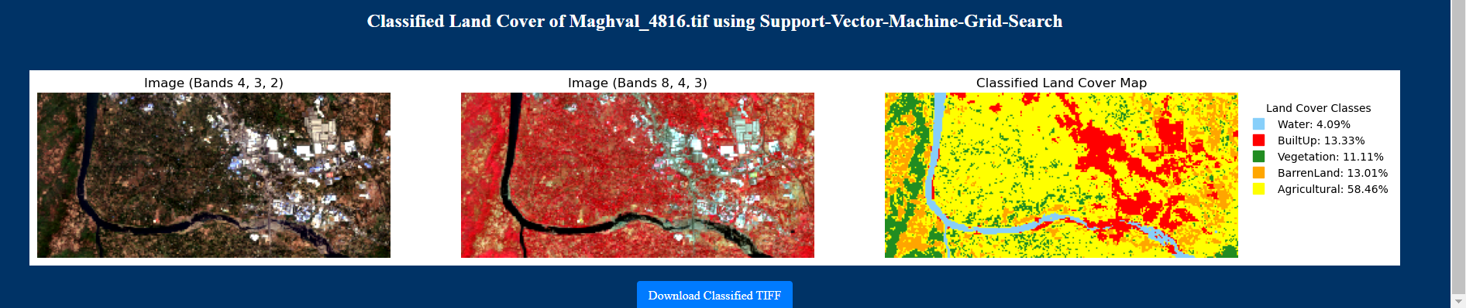

Figure 17 Maghval Classified Map using Support Vector Machine Grid Search

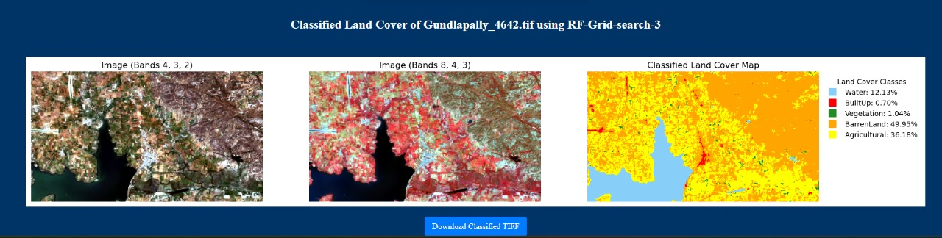

Figure 18 Gundlapally Classified Map using Random Forest Grid Search

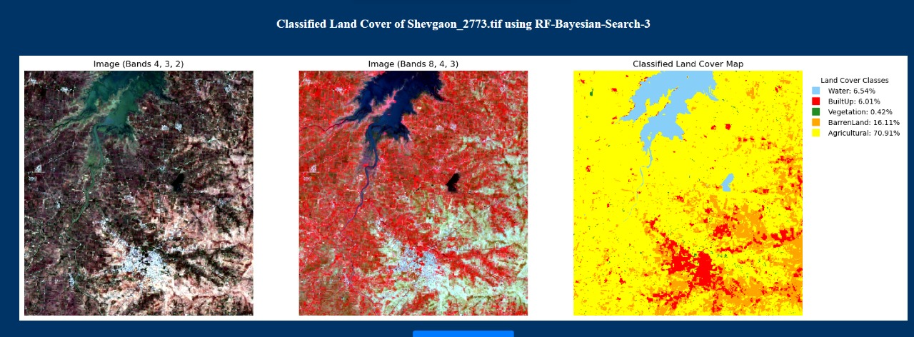

Figure 19 Shevgaon Classified Map using Random Forest Bayesian Search

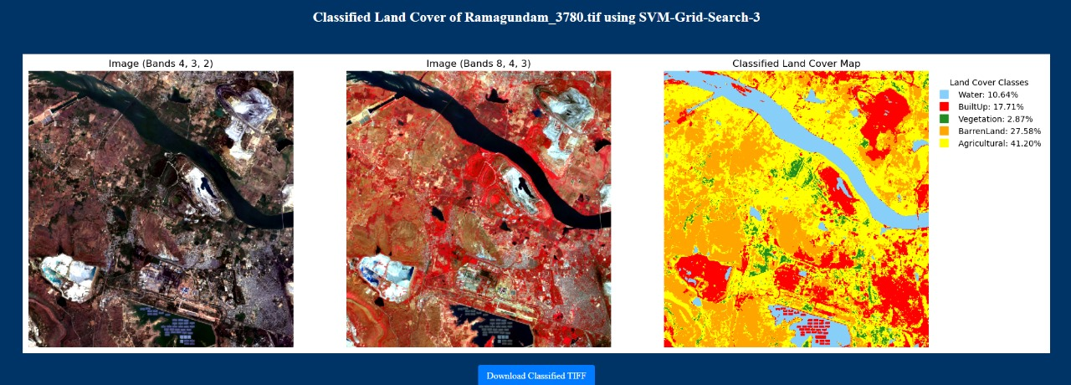

Figure 20 Ramagundam Classified Map using Support Vector Machine Grid Search

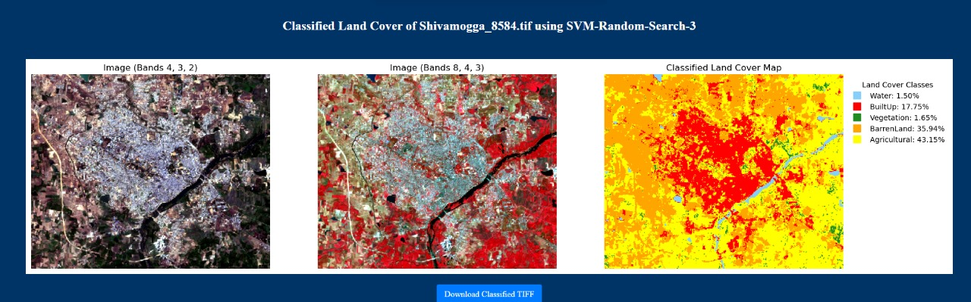

Figure 21 Shivamogga Classified Map using Support Vector Machine Random Search

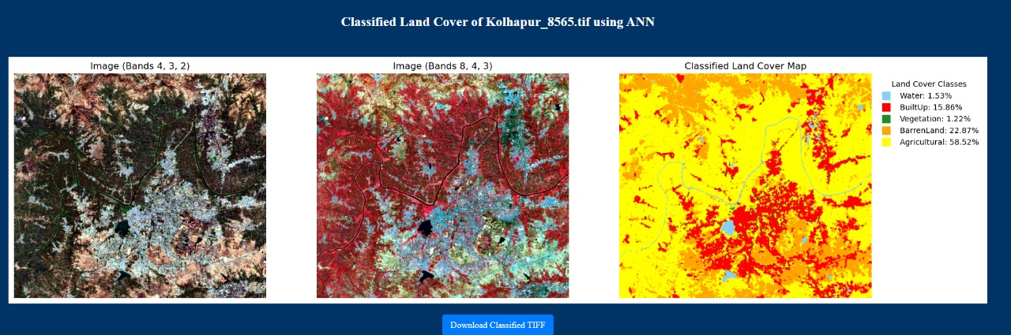

Figure 22 Kolhapur Classified Map using Artificial Neural Network

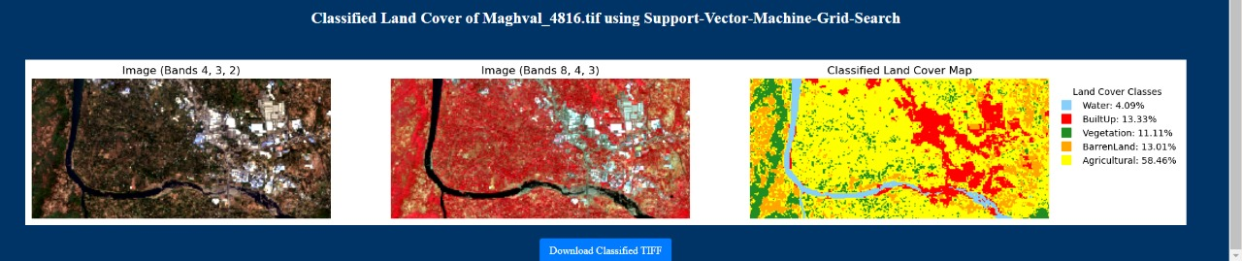

Figure 23 Maghval Classified Map using Support Vector Machine Grid Search

**Classified Map output from different models for different regions**

# CHAPTER 7

# DISCUSSION AND CONCLUSION

This chapter synthesizes the findings from the results and analysis chapter, drawing conclusions in relation to the research objectives, literature, and broader implications. It also discusses the limitations of the study, offers recommendations for future research, and provides concluding remarks on the overall study.

## 7.1. Synthesis of key Findings

This research focused on comparing various machine learning models for Land Use and Land Cover (LULC) classification using satellite imagery. Traditional classification methods have struggled with the non-linear and complex nature of LULC data, prompting the adoption of more advanced machine learning and deep learning approaches. The models explored in this study include Support Vector Machine (SVM), Random Forest (RF), and Artificial Neural Networks (ANN), each offering unique advantages for LULC classification.

The comparative analysis revealed that deep learning models, particularly ANN, outperformed traditional machine learning models like SVM and RF in capturing the intricate patterns inherent in LULC data. ANN demonstrated superior accuracy, especially in distinguishing complex land cover types such as Built-Up areas, which often feature mixed elements like vegetation, roads, and buildings. While SVM and RF also performed robustly, particularly in classifying Vegetation and Water classes, they required more careful hyperparameter tuning to achieve optimal results.

An additional strength of this research lies in the use of satellite data from sources such as Copernicus, which provides high-resolution images of any area in the world. The integration of such data ensures that the classification models can be applied to a global scale, enhancing their utility for diverse geographic regions. The development of an API to facilitate LULC classification, capable of taking user-uploaded TIFF files and processing them with pre-trained models, opens new avenues for remote sensing applications. This API will be particularly useful for researchers and practitioners working in land management, conservation, and environmental monitoring, allowing them to classify land cover types quickly and efficiently

## 7.2. Implications of the Findings

#### The implications of these findings are far-reaching, particularly for environmental monitoring and land management. The demonstrated accuracy and generalization capabilities of ANN, when combined with the robustness of traditional models like SVM and RF, provide a scalable and flexible solution for LULC classification. This research contributes to the development of more accurate models, which are critical for informing land management practices, shaping conservation efforts, and guiding policy-making related to land use.

#### In practical terms, this study illustrates that the combination of machine learning and deep learning models can significantly improve the classification of complex environmental datasets. The ability of these models to handle diverse data from various satellite sources, such as Copernicus, ensures that they can be applied to a wide range of environmental contexts. For instance, land cover classification tasks related to urban planning, agriculture, or deforestation monitoring could greatly benefit from the versatility of the models developed in this research.

#### The successful implementation of the models in an API format further underscores their practical relevance. By allowing users to upload custom data and obtain LULC classifications quickly, the API serves as a valuable tool for anyone engaged in remote sensing or environmental monitoring. Its flexibility and ease of use make it particularly appealing for real-world applications where timely and accurate LULC data is essential.

## 7.3. Limitations of the Study

1. Despite the promising results, there are limitations to the current study that must be addressed in future work. When users upload their own data, noise in the satellite images or inconsistencies in the datasets may negatively affect model performance. This is especially true in regions where the land cover types are highly heterogeneous, making classification more challenging.
2. Another limitation arises from the static nature of the pre-trained models, which may not always generalize well to new datasets that differ significantly from the training data. To overcome this, transfer learning could be employed to adapt the pre-trained models to new environments. By fine-tuning the models on user-uploaded data, the classification accuracy can be improved, ensuring that the models remain effective even when applied to unfamiliar geographic regions or novel land cover types.
3. Finally, the study acknowledges that while the RF model showed the highest accuracy, it also required significant computational resources. This might limit its applicability in scenarios where real-time classification is needed, or where computational power is limited. Future research should explore strategies for optimizing the performance of RF models while maintaining their high classification accuracy.

In conclusion, while this research has made significant strides in improving LULC classification through machine learning, there are opportunities for further refinement and optimization. By addressing the current limitations, this work can be extended to provide even more powerful tools for environmental monitoring and land management

## 7.4. Recommendations for Further Research

The current study has laid a strong foundation for Land Use and Land Cover (LULC) classification using advanced machine learning and deep learning models. However, there are several areas where further research and development can significantly enhance the applicability, efficiency, and scalability of the models and the API. The following recommendations highlight future research directions aimed at improving the system’s overall functionality and its real-world application.

### 7.4.1 Creating an Application for Public Use

A key recommendation is to develop a user-friendly application based on the existing API, making it accessible to the public. This application would allow non-experts, such as local environmental managers, urban planners, or educators, to upload satellite images and receive classified LULC maps in real-time. Simplifying the interface while maintaining high functionality would ensure broader adoption and make the tool useful in various sectors, including agriculture, forestry, and urban development. Incorporating an intuitive graphical user interface (GUI), clear instructions, and optional parameter tuning would enable individuals with limited technical knowledge to effectively utilize the models for LULC classification.

### 7.4.2 Running the API on a Virtual Private Server for Confidential Institutes

To increase the security and reliability of the LULC classification tool, further research should focus on deploying the API on a Virtual Private Server (VPS), especially for use by confidential institutions like the National Remote Sensing Centre (NRSC) or the Indian Space Research Organisation (ISRO). These institutions require a secure and scalable platform to process sensitive satellite data, and hosting the API on a dedicated VPS would provide the necessary infrastructure. By incorporating robust encryption, user authentication, and secure data handling protocols, the API can be tailored for organizations where data confidentiality is paramount.

Running the API on a VPS would also allow for high computational efficiency and the ability to handle larger datasets without impacting performance. Additionally, this setup would enable continuous system updates, maintenance, and the incorporation of new models without downtime or disruptions for the end users.

### 7.4.3 Integration with MongoDB or Other Database Servers to Store History and Results of Previous Use Cases

An important next step in developing the LULC classification system is to integrate it with a database, such as MongoDB or other database servers, to store user history, input data, and classification results. This would provide a record of past classification tasks, allowing users to review previous analyses, compare results, and track changes over time.

The database integration would offer several benefits, including:

Data storage and retrieval: Users could revisit previous classification tasks and download the results at any time.

Improved analysis: By tracking historical data, patterns of land use change could be identified over time, providing additional insights for environmental monitoring.

Efficiency: The system could pre-load previously classified data, speeding up future tasks and reducing redundant computation.

This functionality would also support collaborations between different teams or organizations working on the same dataset, as they could easily share results and contribute to a collective repository of classified images and land cover types.

### 7.4.4 Allowing Fine Tuning and Transfer Learning for Model

To further improve the performance of the LULC classification models, it is recommended to implement fine-tuning and transfer learning capabilities. These approaches would allow users to adapt pre-trained models to specific datasets or regions, improving accuracy when the model encounters new or unseen data.

Fine-tuning: This technique involves adjusting the pre-trained model’s parameters to make it more responsive to the nuances of a particular dataset. By offering fine-tuning as an option, users could optimize the models based on local environmental characteristics, achieving better classification results.

Transfer learning: Transfer learning would enable users to build on the knowledge gained from one dataset and apply it to another. For example, a model trained on LULC data from Europe could be adapted to classify land cover in Asia without needing to be retrained from scratch.

Providing these advanced capabilities within the API will empower users working in unique geographic or environmental contexts to generate more precise and accurate land cover classifications.

### 7.4.5 Including a Greater Number of Classes

Currently, the models used in this research classify a limited number of LULC types, such as Vegetation, Built-Up areas, and Water. Expanding the number of land cover classes would enhance the granularity of classification and improve its applicability to a wider range of real-world scenarios.

Further research should focus on:

Adding more specialized classes: Categories like Cropland, Grassland, Wetlands, Snow/Ice, and Forest could be incorporated to cover more diverse land cover types.

Hierarchical classification: Building a more detailed hierarchical structure of LULC classes could allow users to classify land cover at multiple levels, from broad categories (e.g., Vegetation) to more specific subtypes (e.g., Tropical Rainforest, Temperate Forest).

The inclusion of additional classes would require training the models on more diverse datasets, ensuring that the expanded classification system remains accurate across a wide variety of land cover types.

### 7.4.6 Increasing the Training Dataset Sample Size

To improve the performance and generalizability of the models, further research should focus on increasing the size and diversity of the training datasets. Currently, the models perform well, but increasing the training dataset sample size would:

Improve model accuracy: More data allows the model to better learn complex patterns and relationships in the LULC data.

Reduce overfitting: A larger, more varied dataset helps the model generalize better, avoiding overfitting to specific regions or data types.

Enhance robustness: By incorporating data from multiple satellite sources, different geographic regions, and varying resolutions, the models would become more robust and adaptable.

Collaborating with global initiatives, such as Google Earth Engine, and leveraging datasets from different sources, such as Sentinel and Landsat, could greatly expand the training dataset and improve classification accuracy across diverse environments.

These recommendations aim to further enhance the LULC classification models and API, ensuring they become more accessible, secure, flexible, and capable of handling diverse datasets and real-world applications. By addressing these areas, future research can lead to the development of more powerful tools for environmental monitoring, land management, and policy-making.

### REFERENCES

1. [https://colab.research.google.com/drive/1xgPvOPHJpk4es5jmtCRGw07LG8 GiRw4w?usp=sharing](https://colab.research.google.com/drive/1xgPvOPHJpk4es5jmtCRGw07LG8GiRw4w?usp=sharing)
2. [https://code.earthengine.google.com/44f1a4569cbd38b971e76d5e1677702c?](https://code.earthengine.google.com/44f1a4569cbd38b971e76d5e1677702c?noload=true)

[noload=true](https://code.earthengine.google.com/44f1a4569cbd38b971e76d5e1677702c?noload=true)

1. <https://code.earthengine.google.com/44f1a4569cbd38b971e76d5e1677702c?noload=true>
2. <https://code.earthengine.google.com/2365e8c098cc0ba9dfe9ea0d8f3de78c>
3. <https://code.earthengine.google.com/ea411b2d1b487d5bca2d4a2b04727d70>
4. https://colab.research.google.com/drive/1vySu6gdhYsivMtNSsQZtfjYX0KAOxksf?usp=sharing

### ANNEXURE

1. [https://www.nrsc.gov.in/sites/default/files/pdf/RD_Activities/Applications/1](https://www.nrsc.gov.in/sites/default/files/pdf/RD_Activities/Applications/17.pdf)

[7.pdf](https://www.nrsc.gov.in/sites/default/files/pdf/RD_Activities/Applications/17.pdf)

1. <https://www.geeksforgeeks.org/machine-learning/>
2. [https://www.adobe.com/in/creativecloud/file-types/image/raster/tifffile.html#:~:text=A%20TIFF%2C%20which%20stands%20for,to%20avoid %20lossy%20file%20formats.](https://www.adobe.com/in/creativecloud/file-types/image/raster/tiff-file.html#:~:text=A%20TIFF%2C%20which%20stands%20for,to%20avoid%20lossy%20file%20formats)
3. https://www.nrsc.gov.in/sites/default/files/pdf/ebooks/Chap_7_Geosciences. pdf
4. Land-Use Land Cover Classification by Machine Learning Classifiers for

Satellite Observation-A Review by ―Swapan Talukdar, Pankaj Singha, Susanta Mahata, Shahfahad, Swades Pal, Yuei-An Liou, and Atiqur

Rahman‖

1. Paper code: GEOACORO4T (Cartography and Thematic Mapping) TOPIC (4): Preparation and interpretation of landuse and landcover mapping:

Prepared by Dr. Susanta Pramanik Assistant Professor Department of

Geography